**NAME: BINYANYA DEBORAH NYATICHI**

**CS NO: ADC-CSS02-25051**.

**DESCRIPTION: Week 2 Assignment 3**

**ASSIGNMENT: Lab on Microsoft Identity and Access Management Solutions**

**DATE: 05/04/2025**

# INTRODUCTION

In today's digital landscape, robust identity management is paramount for security, compliance, and user productivity. This lab series is designed to provide you with hands-on experience in key components of Microsoft's cutting-edge IAM platform, Microsoft Entra ID (formerly Azure AD).mThrough a series of focused labs, you will delve into critical functionalities that empower organizations to manage user identities, secure access to resources, and streamline administrative tasks. We will move beyond theoretical concepts and provide practical scenarios where you can configure and observe these powerful features in action.

This lab will guide you through the following essential areas:

* **Explore Microsoft Entra ID User Settings:** Gain a foundational understanding of how user accounts are managed within Microsoft Entra ID, including profile settings, contact information, and organizational relationships.
* **Microsoft Entra self-service password reset (SSPR):** Discover how to empower users to securely reset their own passwords, reducing helpdesk burden and improving user convenience.
* **Microsoft Entra Conditional Access:** Learn how to implement granular access control policies based on various conditions, such as user location, device compliance, and application sensitivity, to enhance security.
* **Explore Privileged Identity Management (PIM):** Understand how to manage, control, and monitor access to important resources within your organization by implementing just-in-time and approval-based privileged access.

# LAB SCENARIOS

Start up your lab

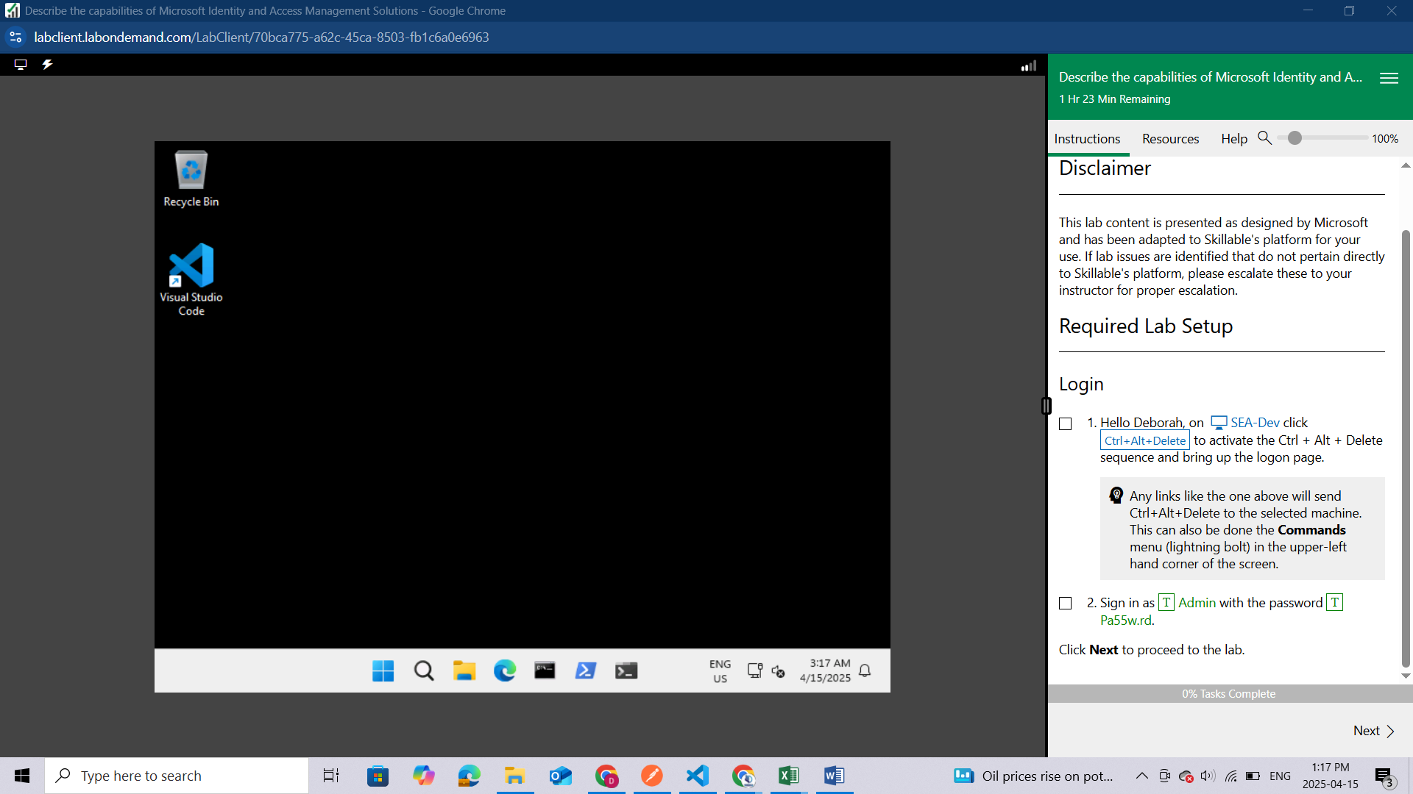

Login to the Admin page and use the password given.

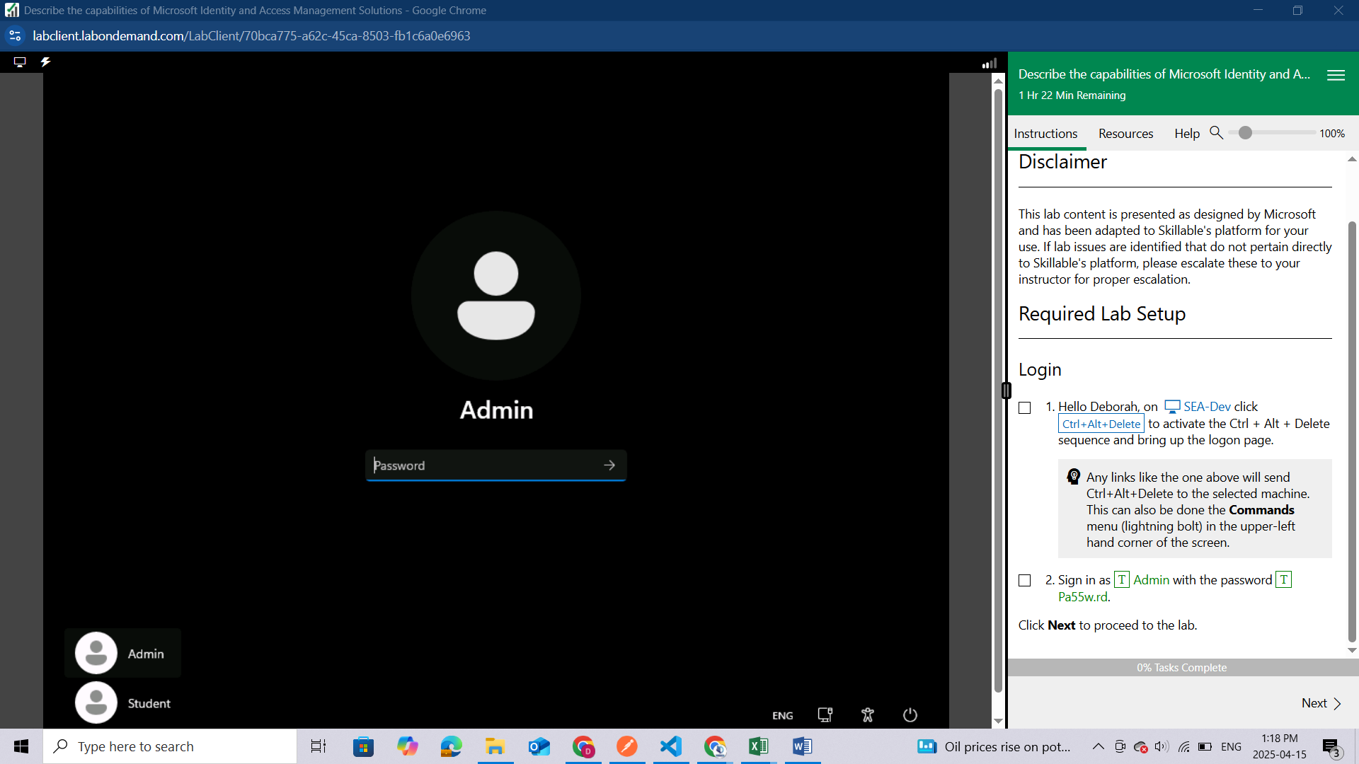

After successful login you will see your machine desktop

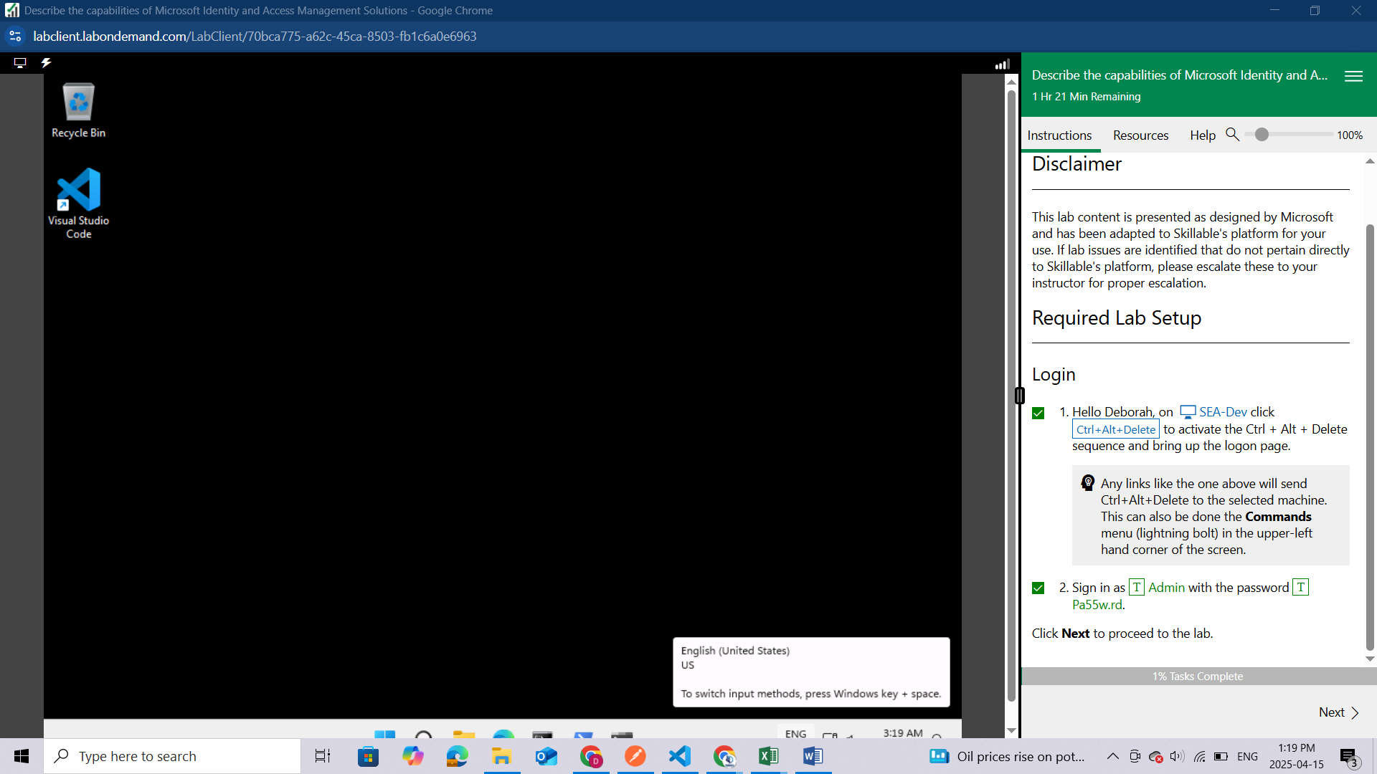

NOTE: These labs are for class purposes and not used to perform cybercrime  
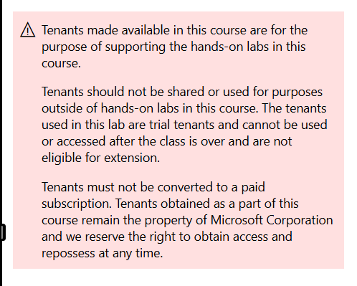

## Setup - Enable Microsoft 365 audit log and file monitoring

In this setup task, you will enable the Audit log and file monitoring capabilities in Microsoft 365.

Open Microsoft Edge. In the address bar, enter [**https://admin.microsoft.com**](https://admin.microsoft.com)

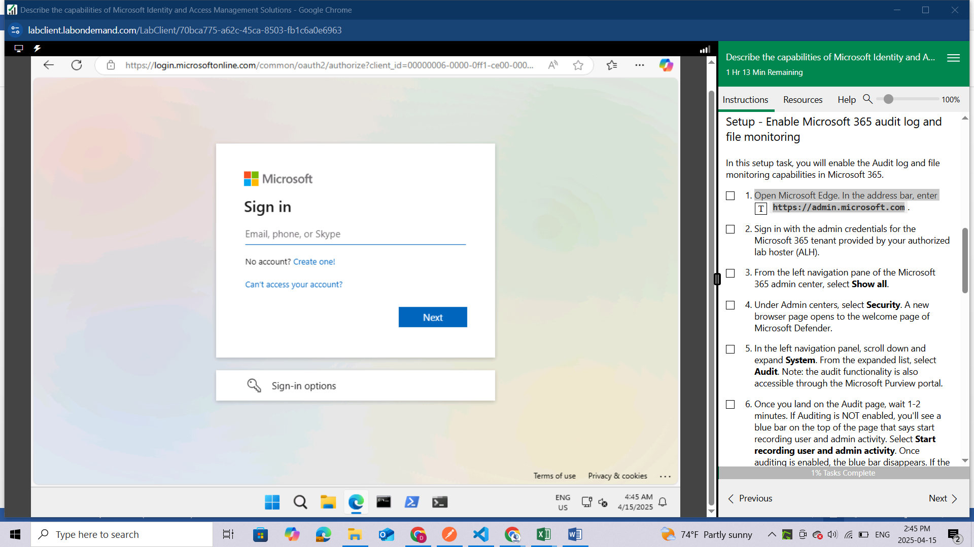

Sign in with the admin credentials for the Microsoft 365 tenant provided by your authorized lab hoster (ALH).

Use the credentials under resources to login

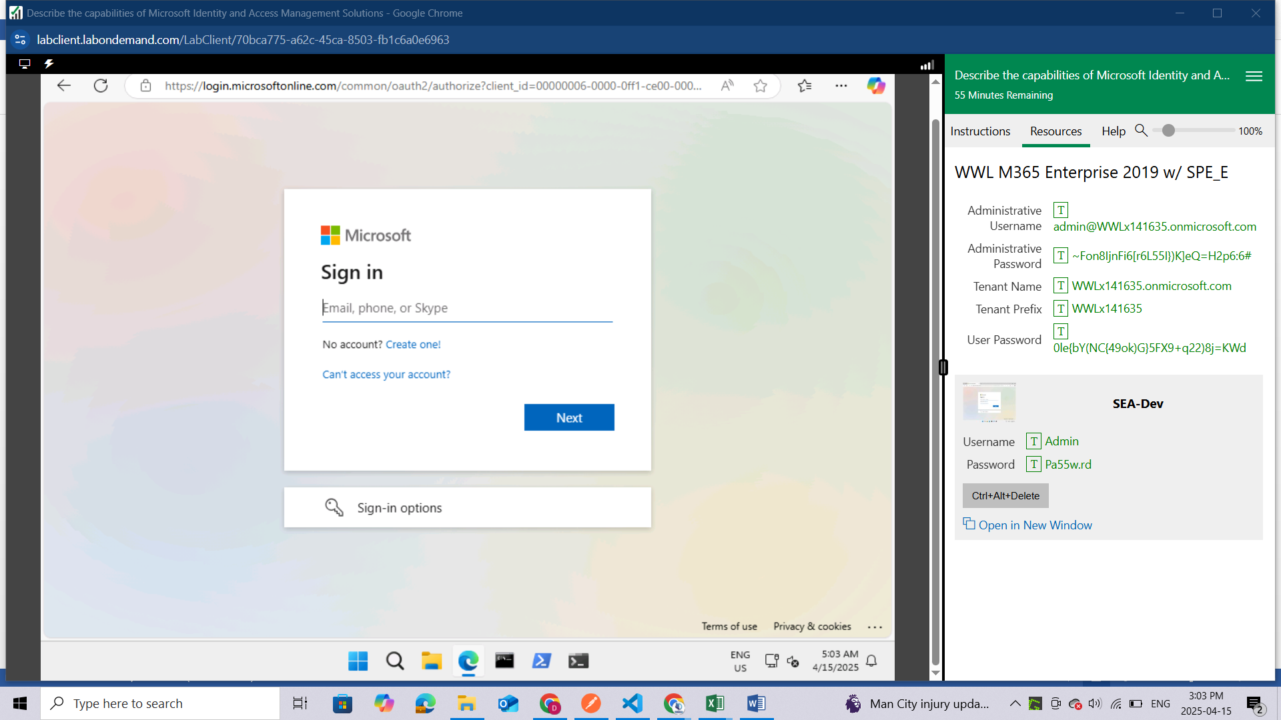

Use admin account for priviledges

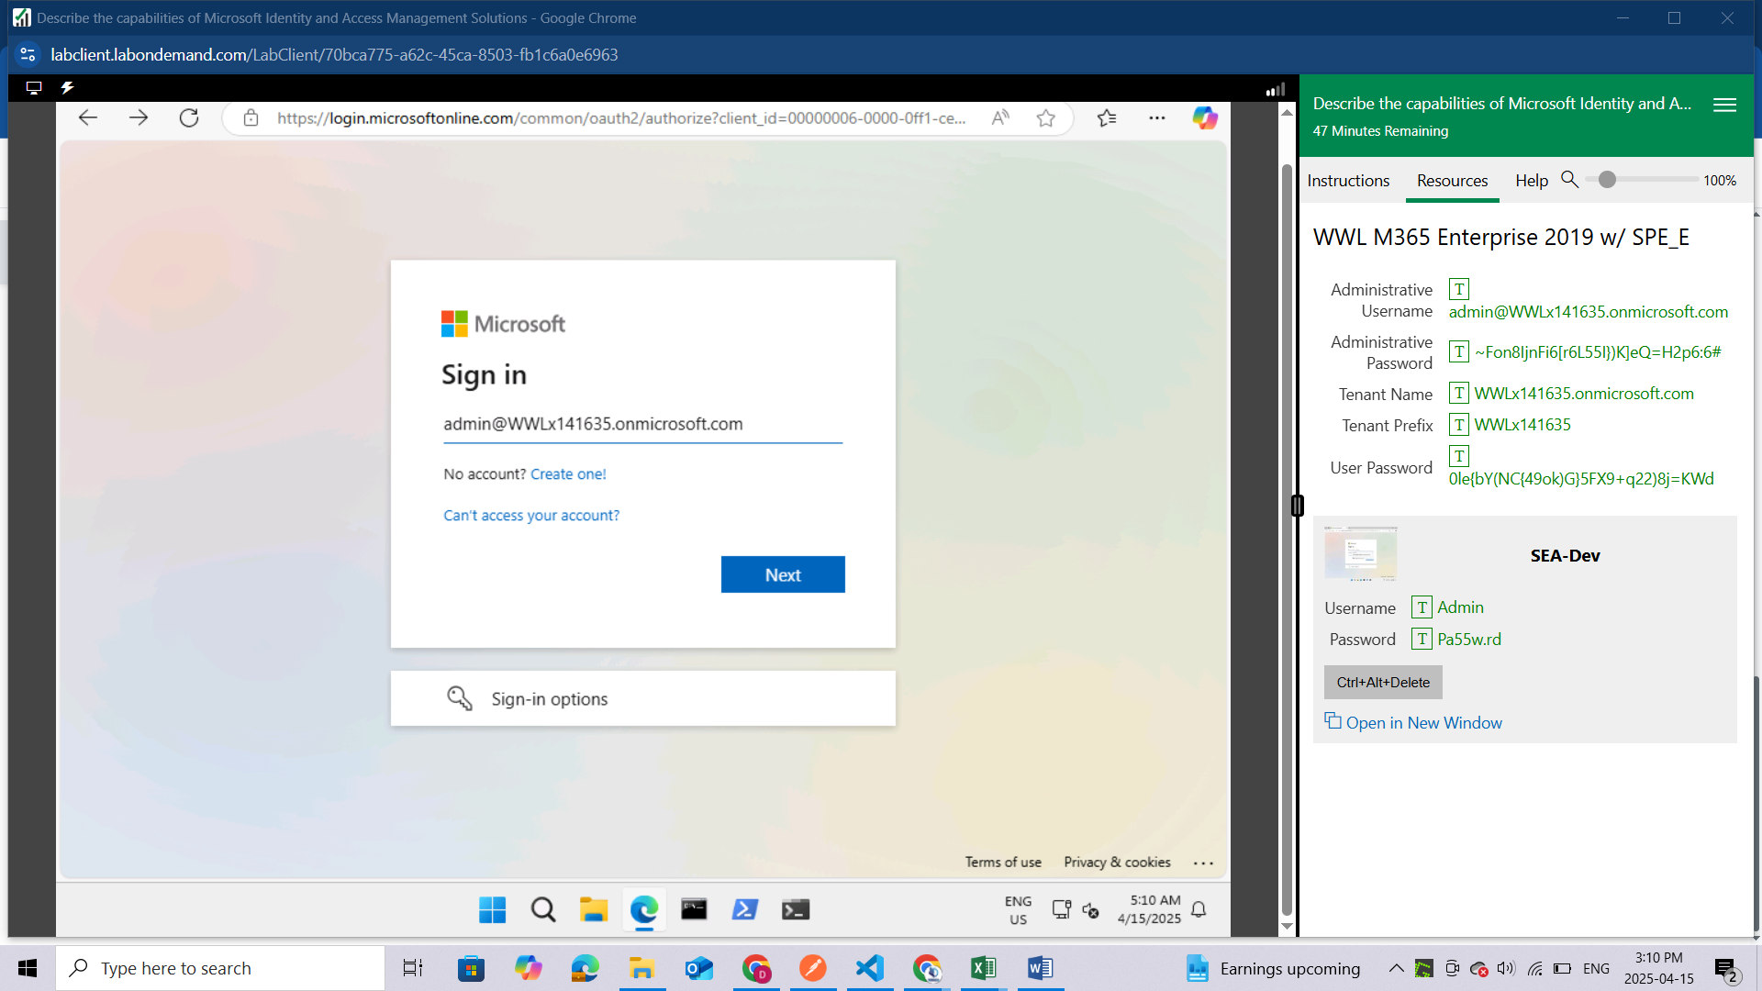

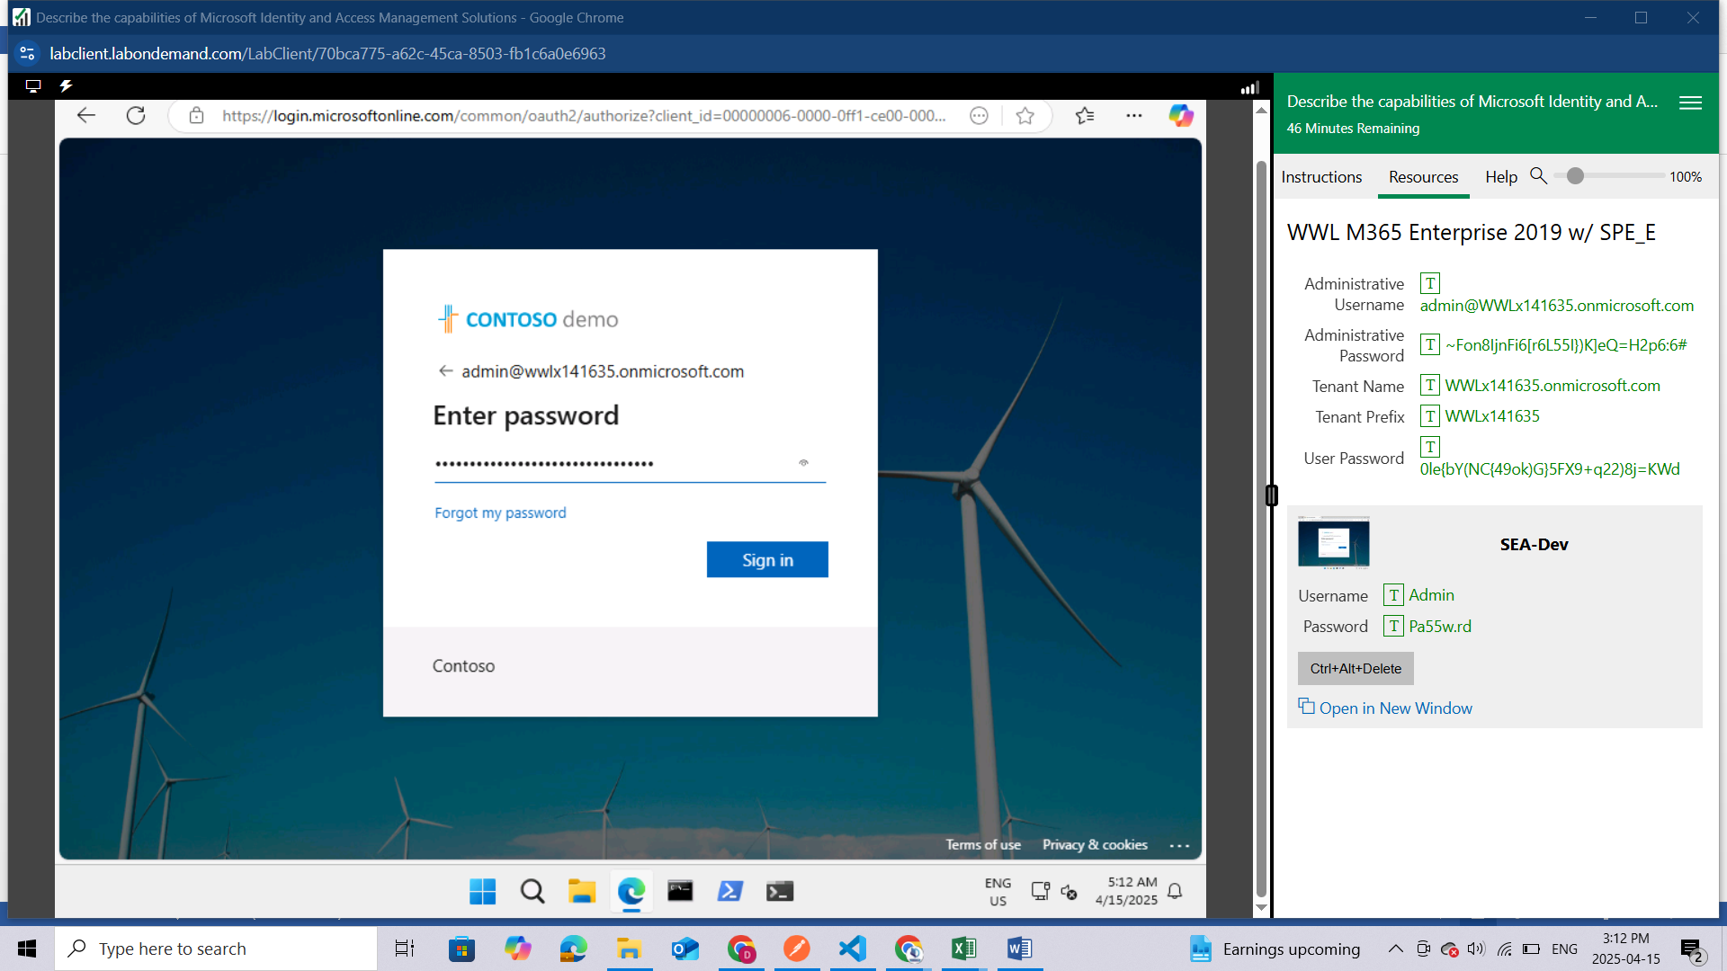

After successful login you will be able to see this page

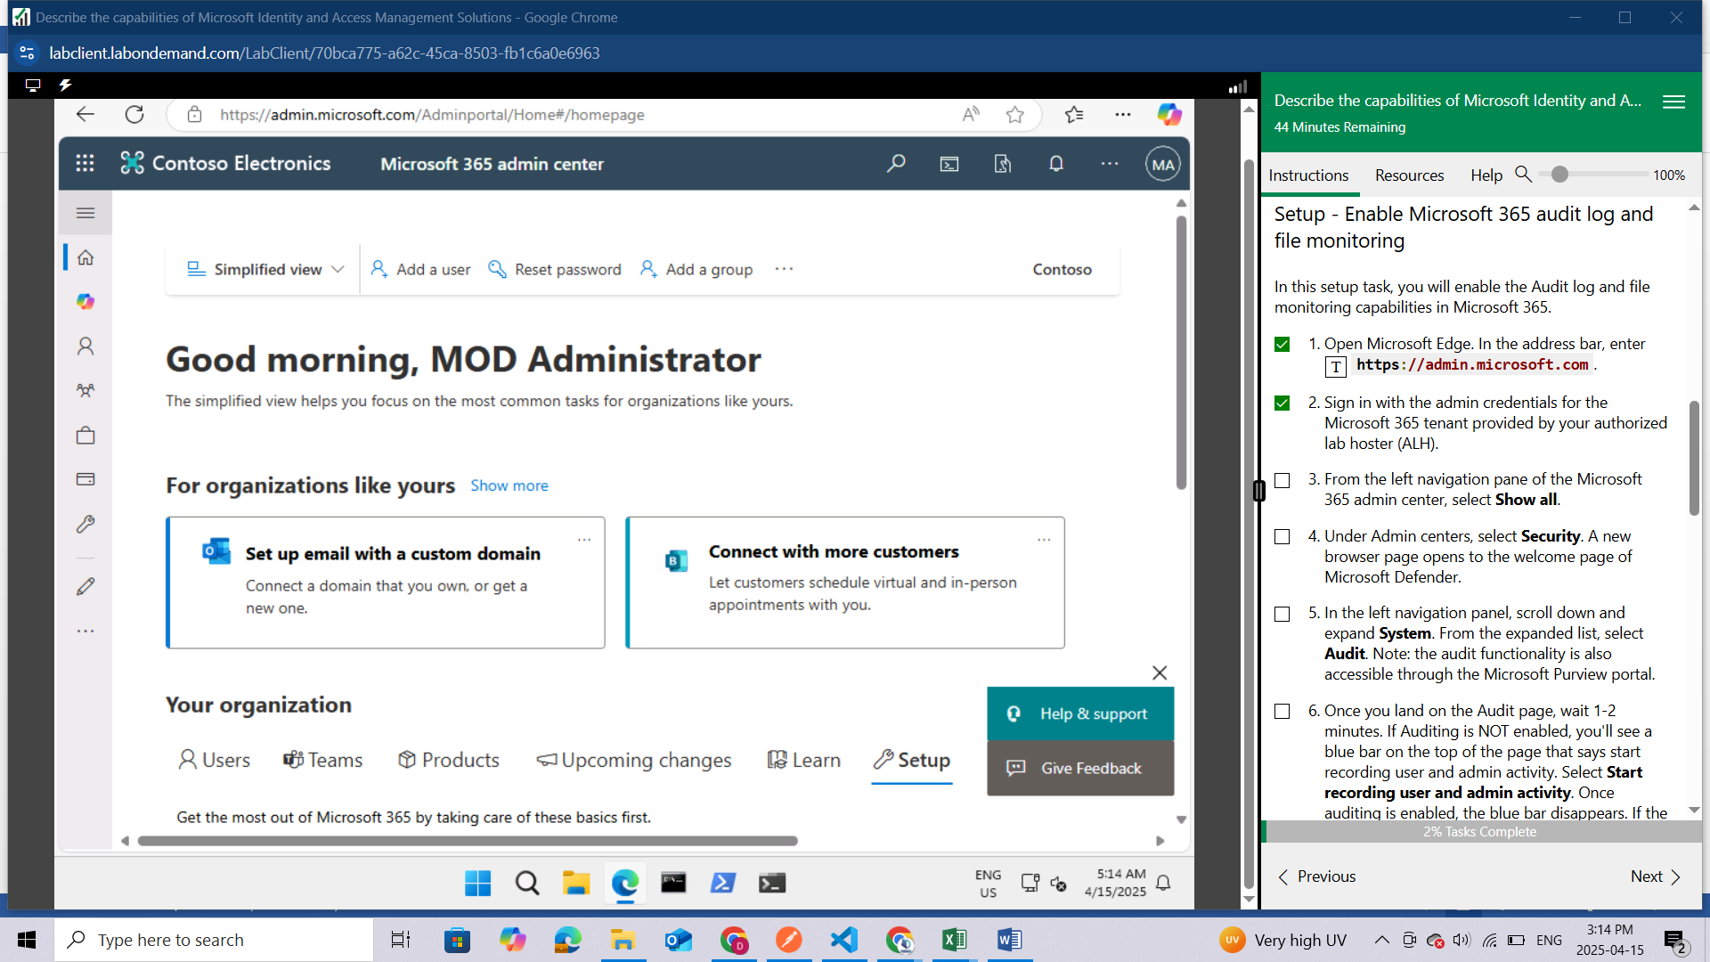

From the left navigation pane of the Microsoft 365 admin center, select **Show all**.

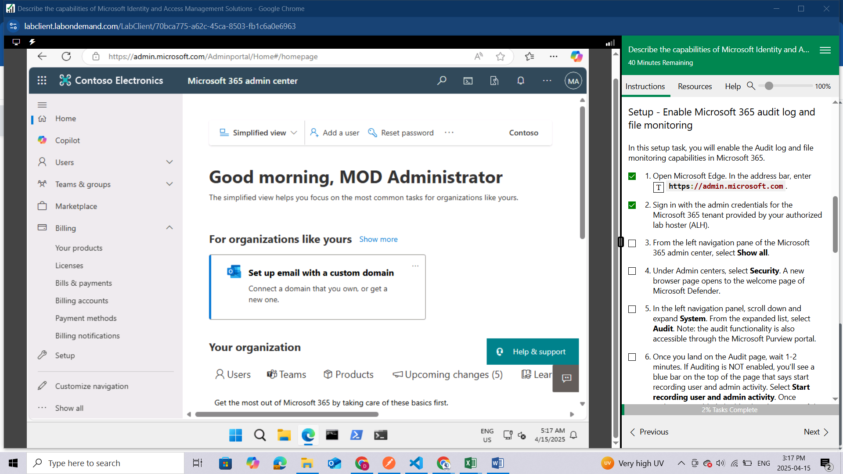

Under Admin centers, select **Security**. 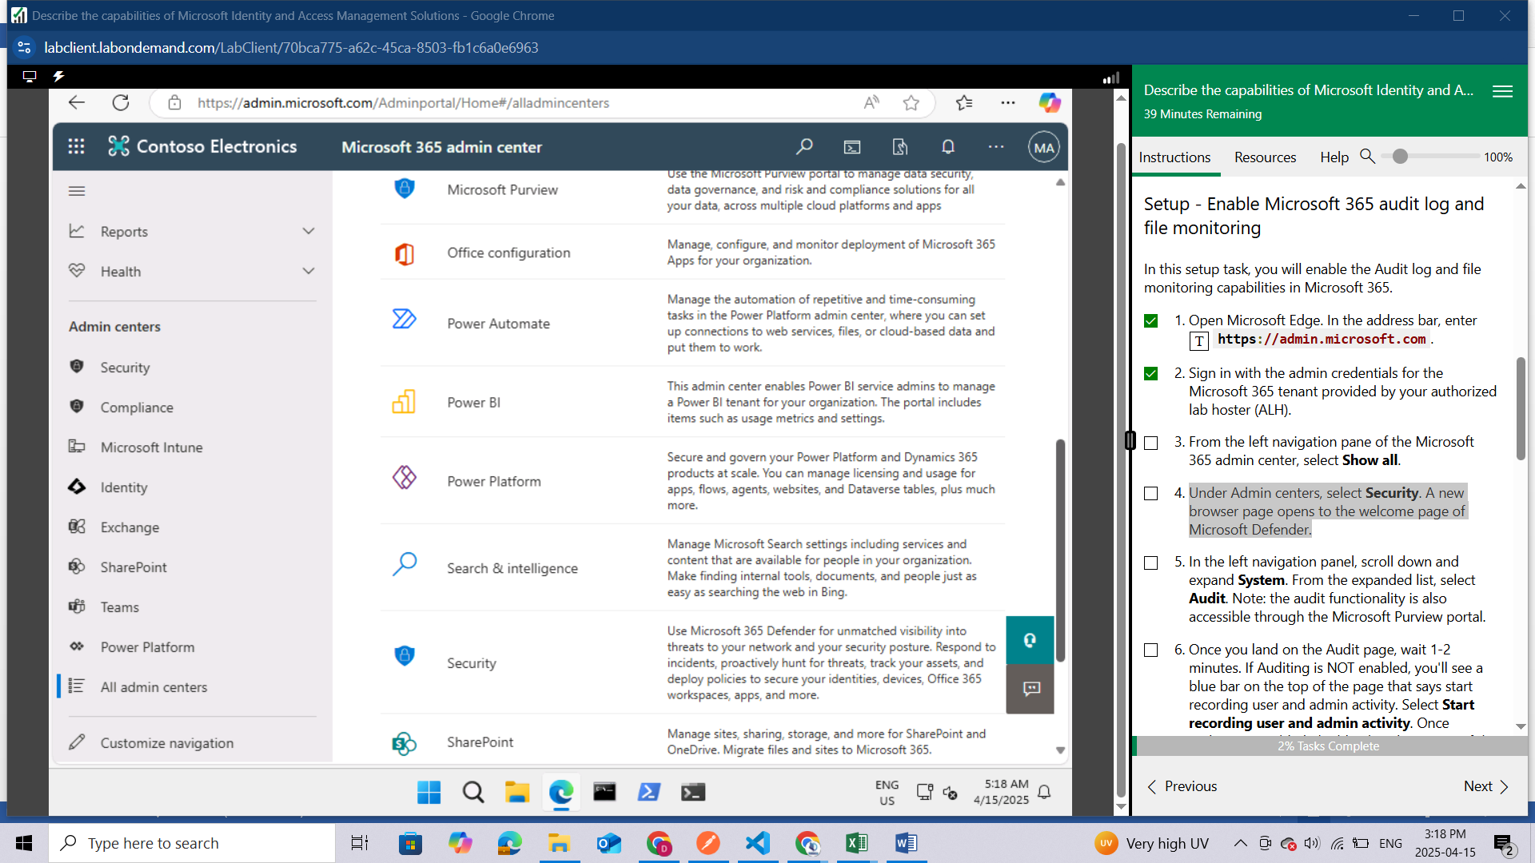

A new browser page opens to the welcome page of Microsoft Defender.

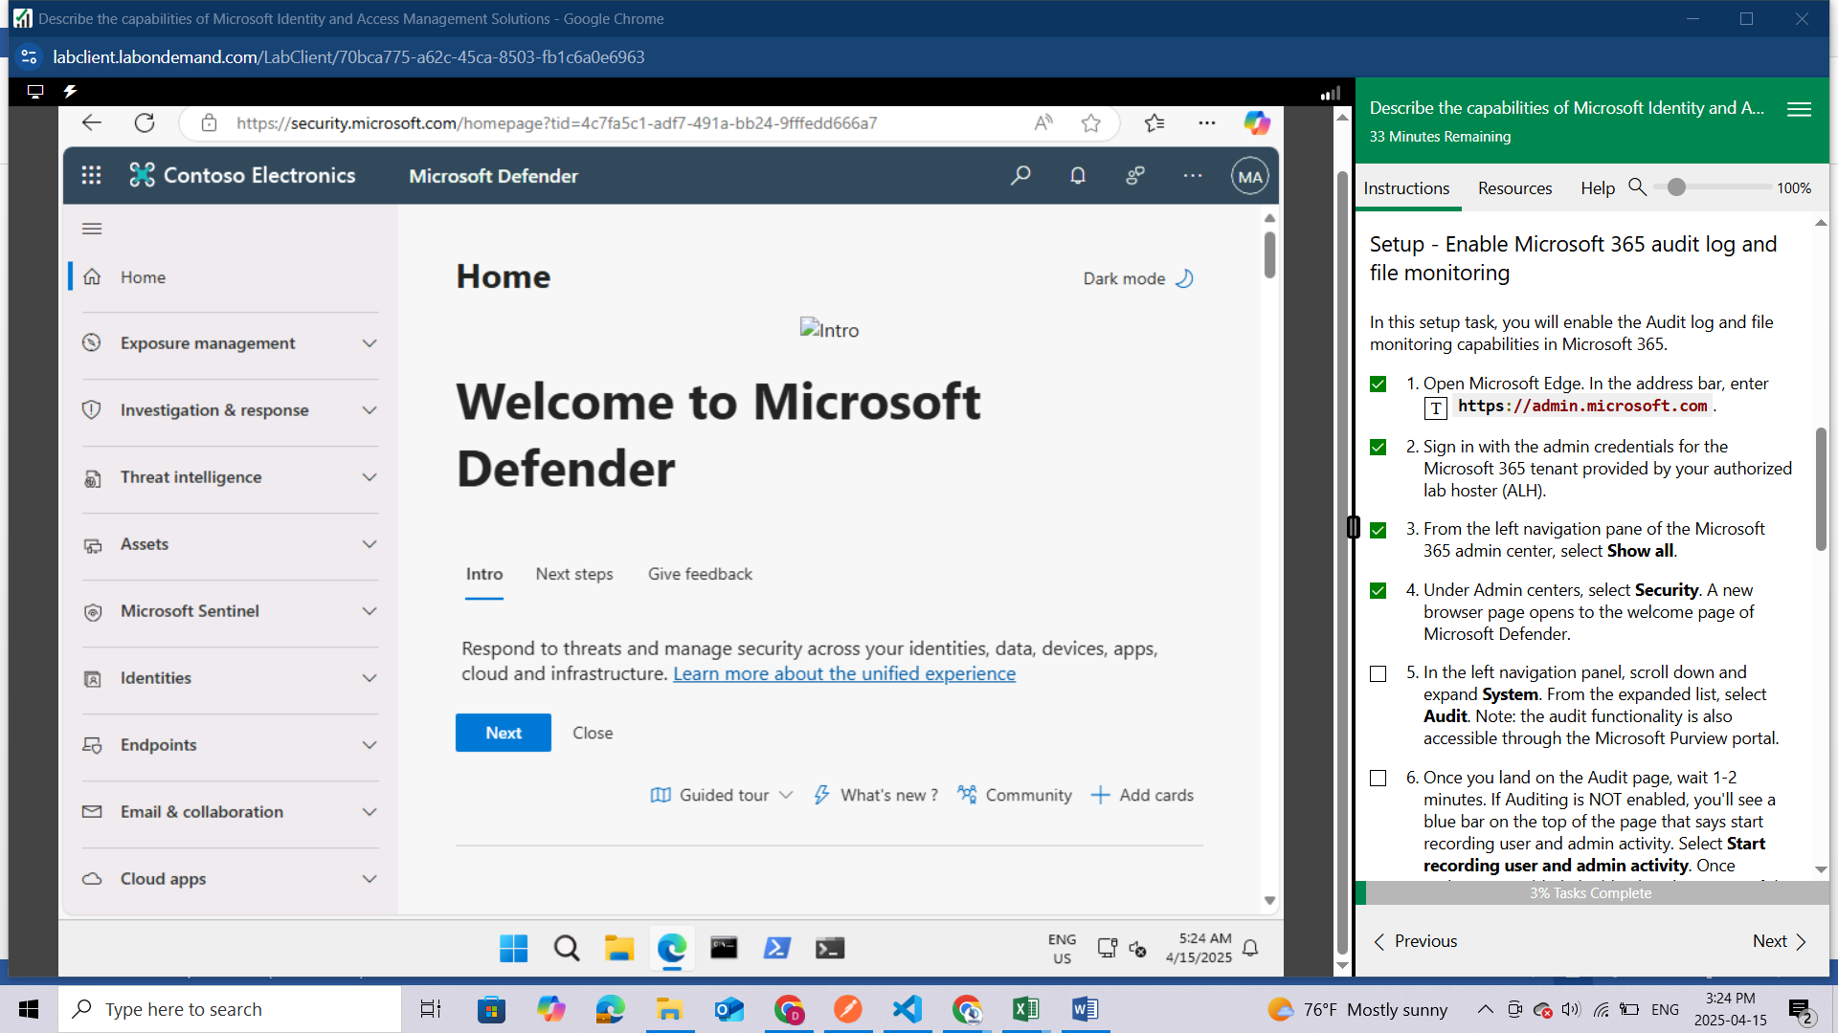

In the left navigation panel, scroll down and expand **System**. From the expanded list, select **Audit**. Note: the audit functionality is also accessible through the Microsoft Purview portal.

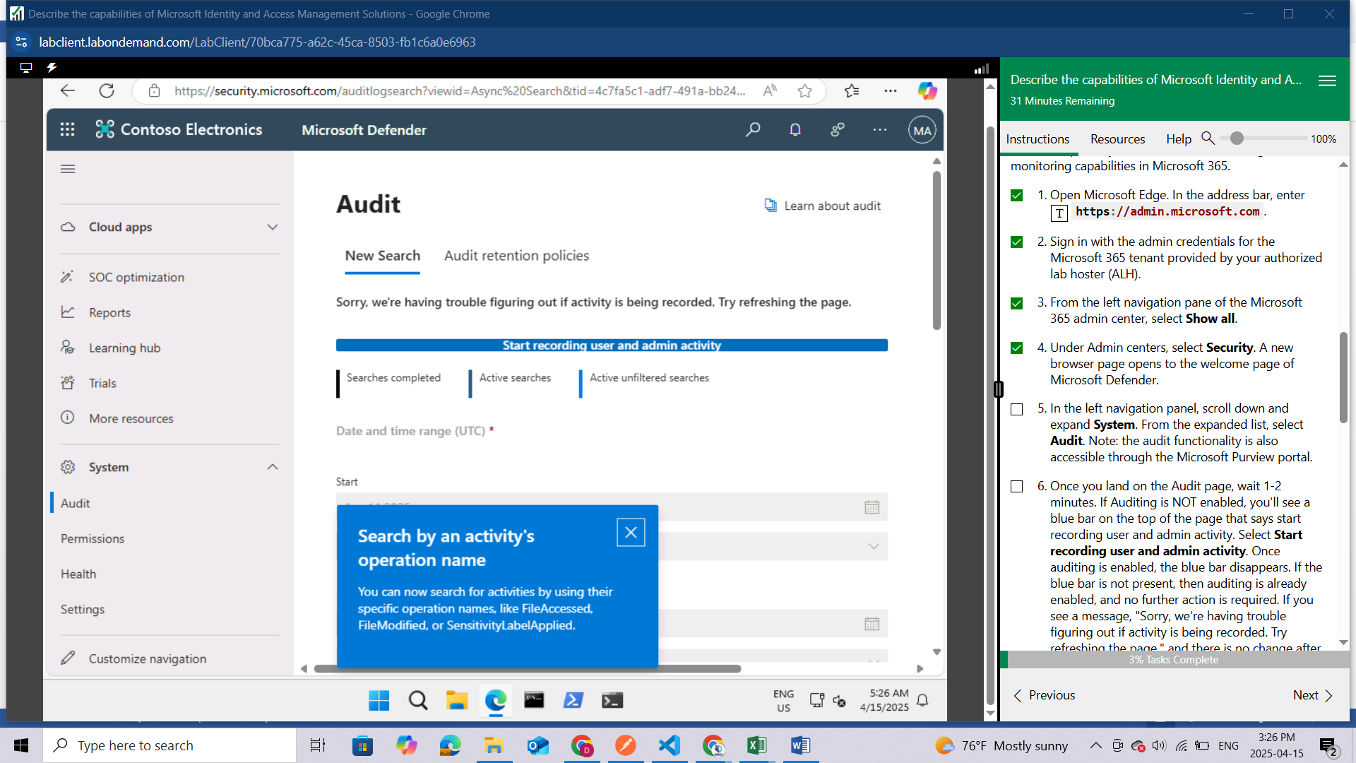

Once you land on the Audit page, wait 1-2 minutes. If Auditing is NOT enabled, you'll see a blue bar on the top of the page that says start recording user and admin activity. Select **Start recording user and admin activity**. Once auditing is enabled, the blue bar disappears. If the blue bar is not present, then auditing is already enabled, and no further action is required.

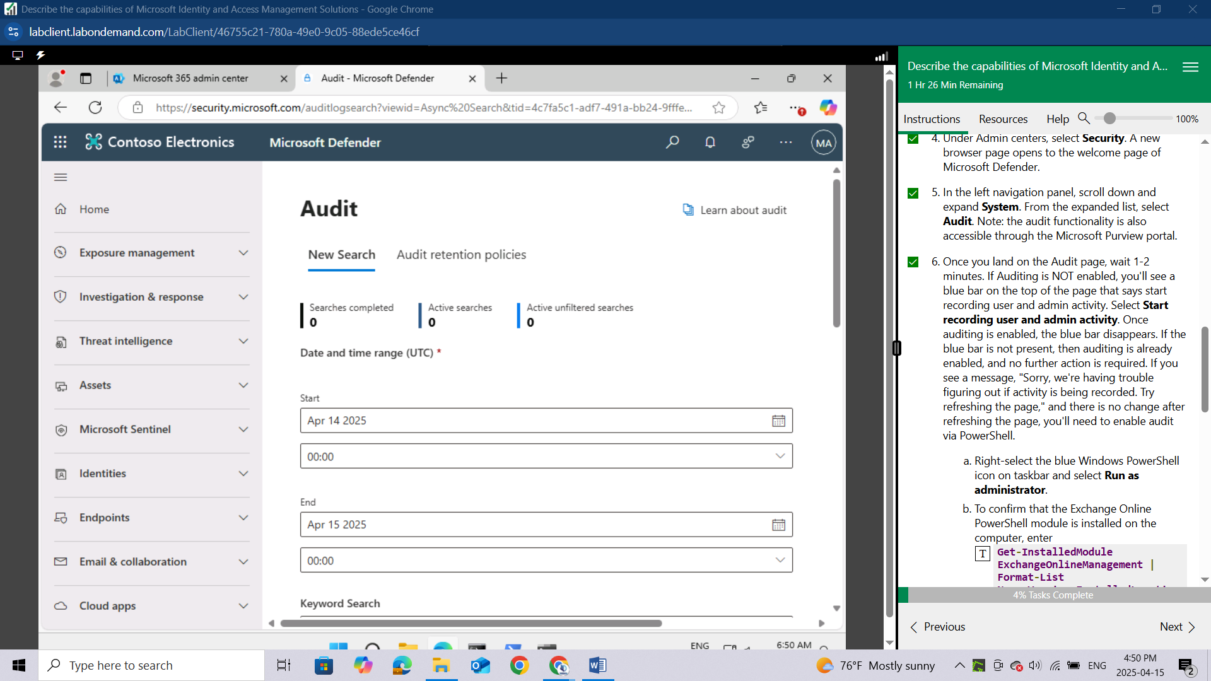

If you see a message, "Sorry, we're having trouble figuring out if activity is being recorded. Try refreshing the page," and there is no change after refreshing the page, you'll need to enable audit via PowerShell.

* 1. Right-select the blue Windows PowerShell icon on taskbar and select **Run as administrator**.
  2. To confirm that the Exchange Online PowerShell module is installed on the computer, enter **Get-InstalledModule ExchangeOnlineManagement | Format-List Name,Version,InstalledLocation**. You'll see the name, version and installed location of Exchange OnlineManagement.
  3. Now load the module, by entering **Import-Module ExchangeOnlineManagement**.
  4. To connect, enter **Connect-ExchangeOnline -UserPrincipalName admin@WWLxZZZZZZ.onmicrosoft.com**. For the UPN, enter the administrator username found in the resources tab of your lab.
  5. You'll be prompted to sign in. Enter the administrative username and password found in the resources tab of your lab.
  6. To turn on Auditing, enter **Set-AdminAuditLogConfig -UnifiedAuditLogIngestionEnabled $true**. A message is displayed saying that it might take up to 60 minutes for the change to take effect.
  7. Although it may take up to 60 minutes to take effect, you can verify the command was received by entering **Get-AdminAuditLogConfig | FL UnifiedAuditLogIngestionEnabled**. If audit is enabled, the property UnifiedAuditLogIngestionEnabled will show a value of true.

From the left navigation panel, under System, select **Settings**

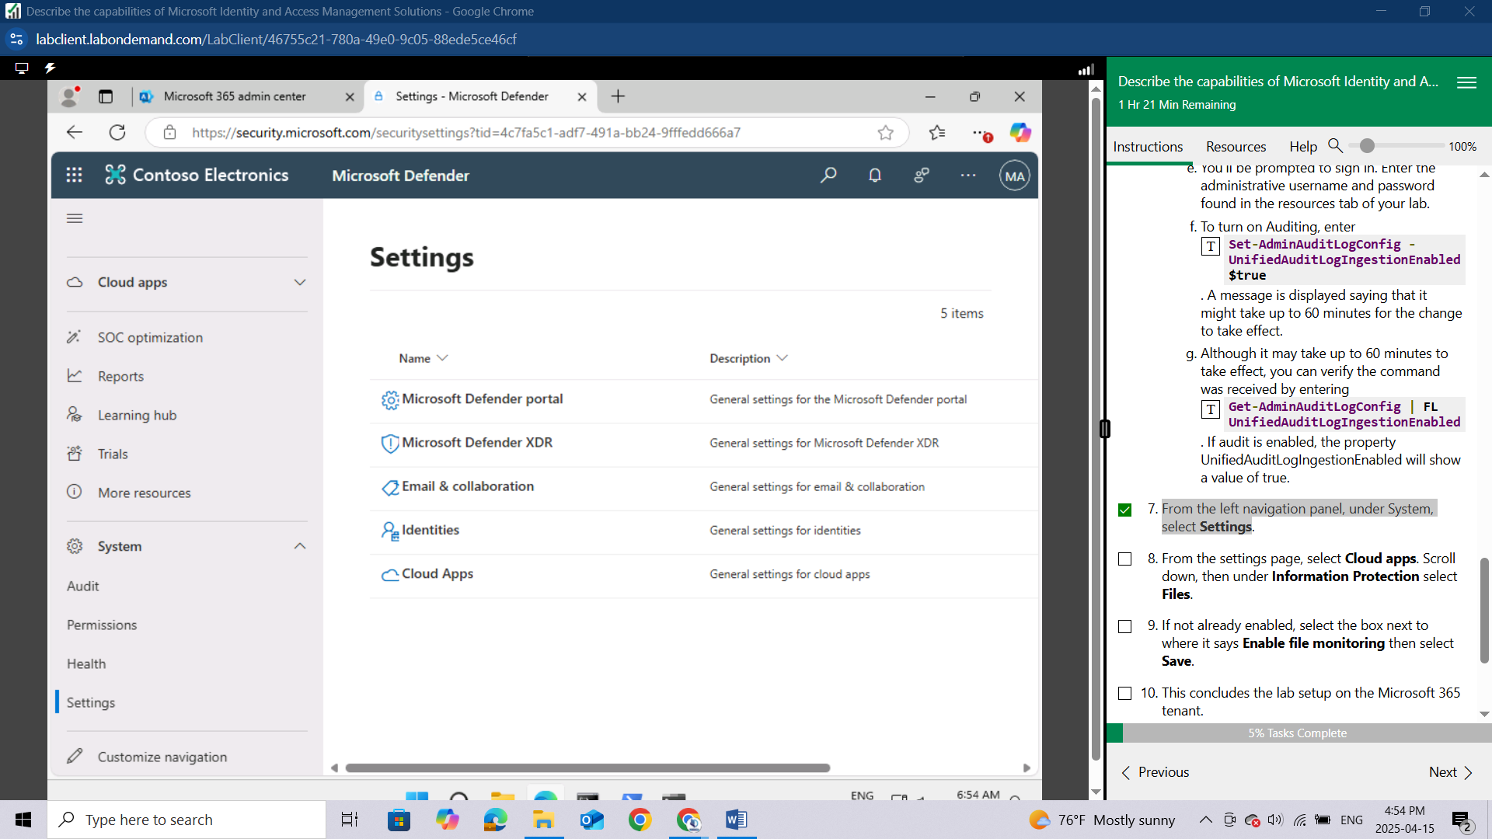

From the settings page, select **Cloud apps**.



Scroll down, then under **Information Protection** select **Files**.

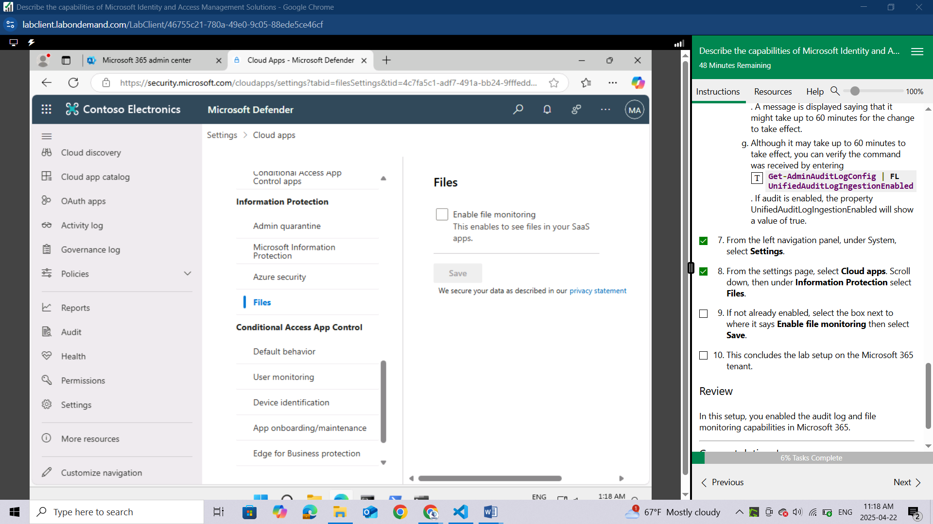

If not already enabled, select the box next to where it says **Enable file monitoring** then select **Save**.

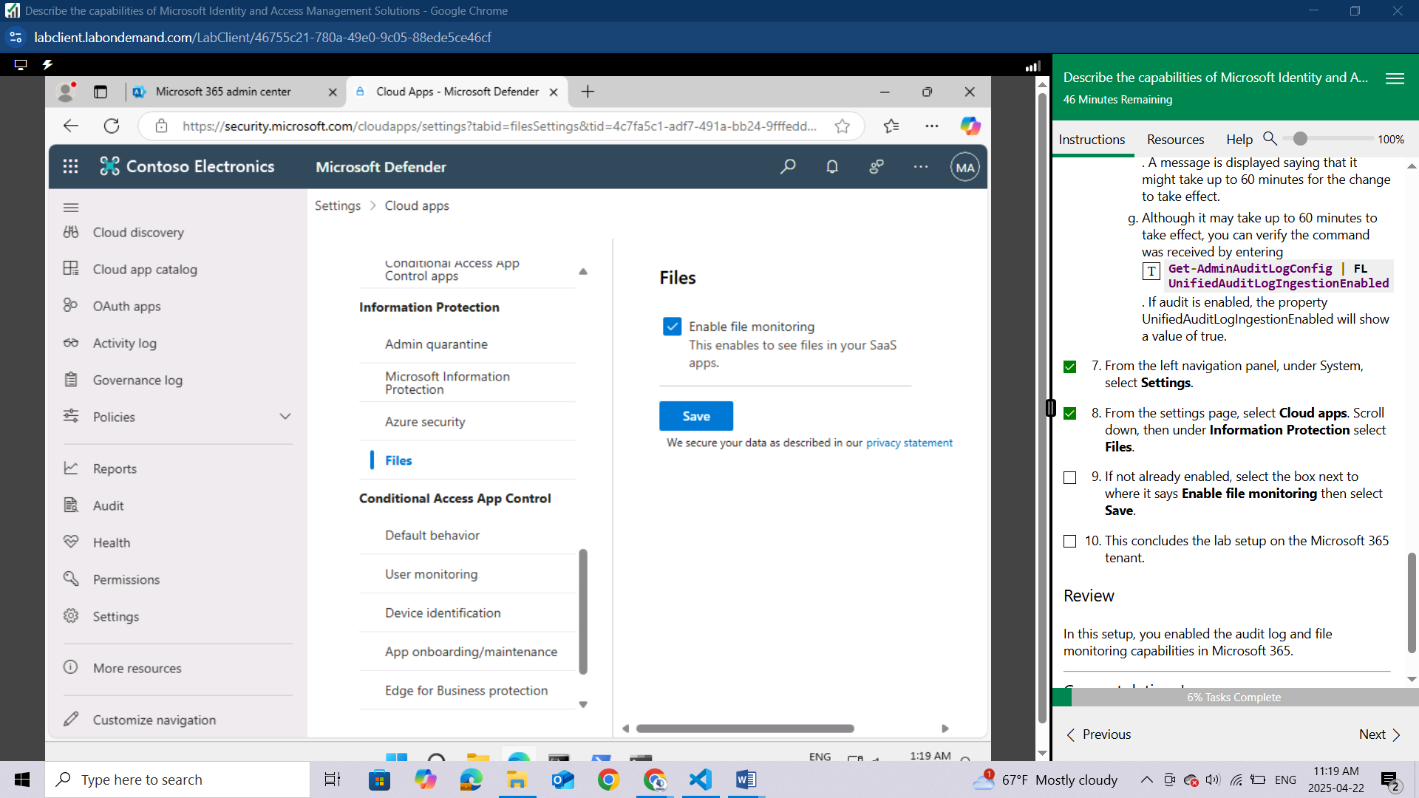

This concludes the lab setup on the Microsoft 365 tenant.

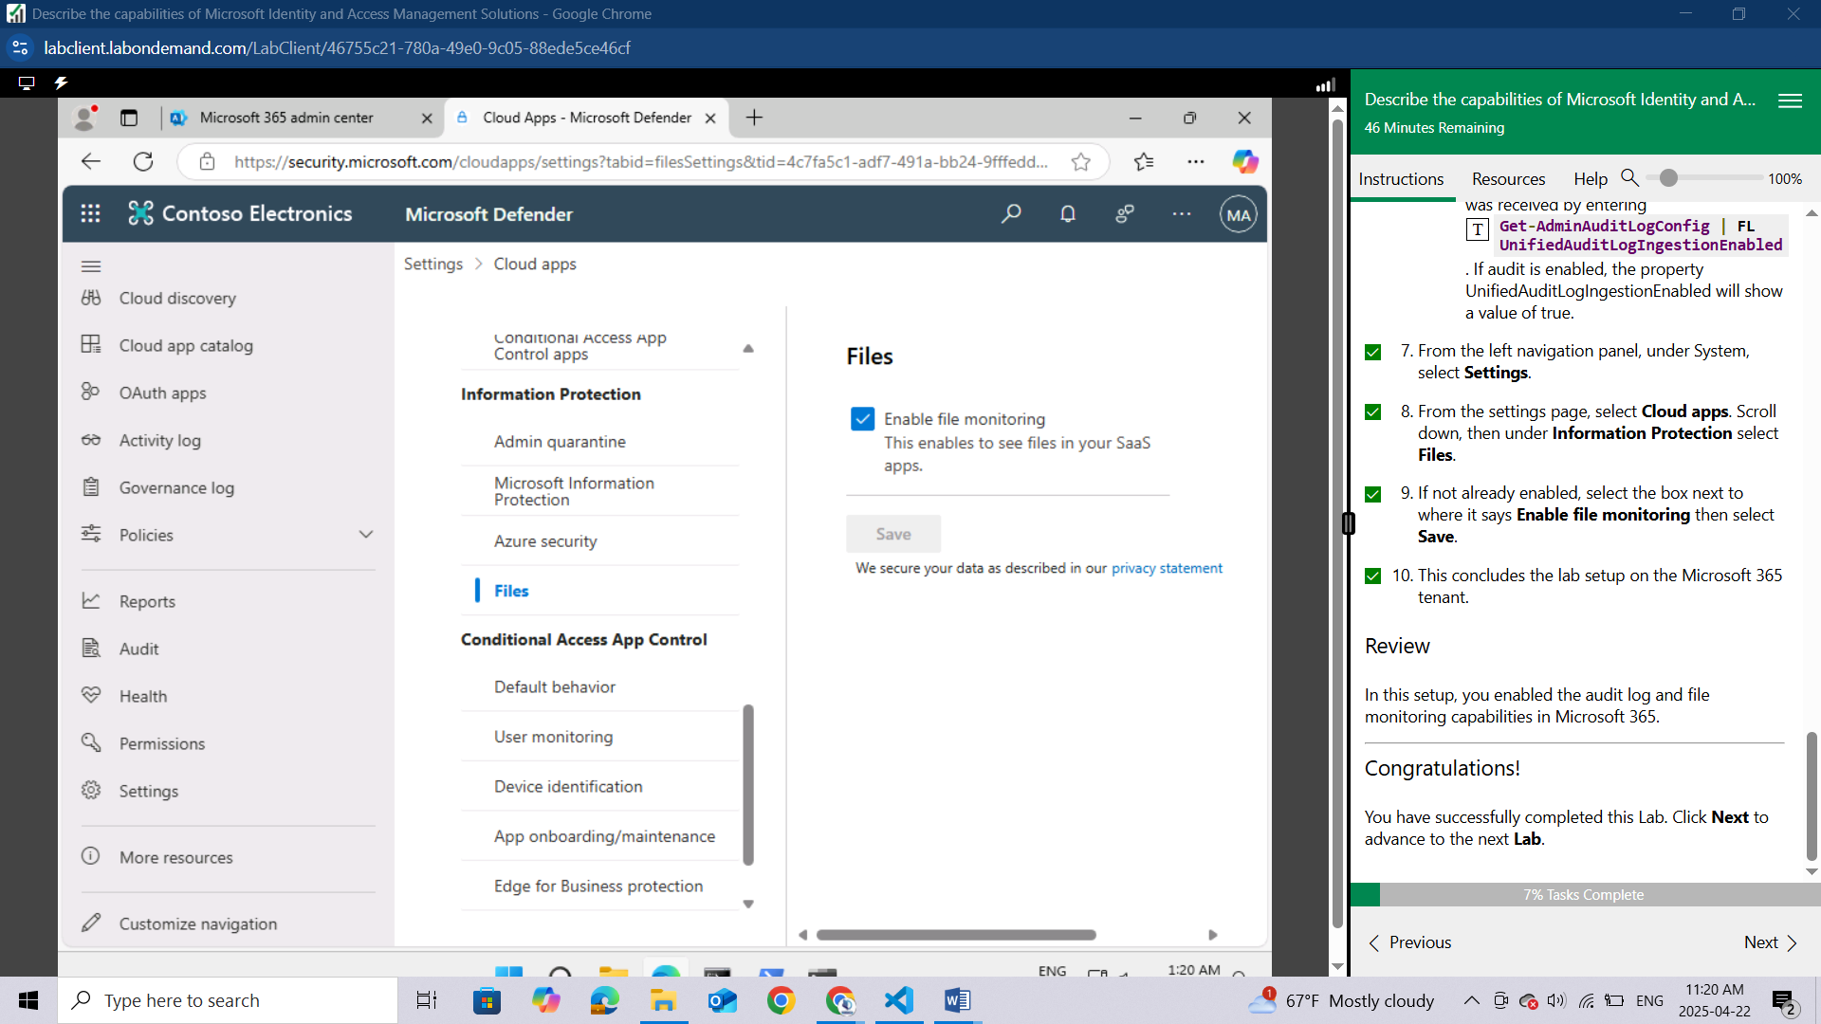

In this lab we have enabled the audit log and file monitoring capabilities in Microsoft 365.

# LAB: EXPLORE MICROSOFT ENTRA ID USER SETTINGS

This lab maps to the following Learn content:

* Learning Path: Describe the capabilities of Microsoft Entra.
* Module: Describe the function and identity types of Microsoft Entra ID.
* Unit: Describe the types of identities.

## Lab scenario

In this lab, you'll access Microsoft Entra ID (previously referred to as Azure Active Directory). Additionally, you'll create a user and configure the different settings, including adding licenses.

### Task 1

As a subscriber to Microsoft 365 you're already using Microsoft Entra ID. In this task, you’ll learn how to create a new user in Microsoft Entra ID and explore some of services that can be managed at the user level.

Open the Microsoft Edge browser. In the address bar, enter <https://admin.microsoft.com> and sign in with the Microsoft 365 credentials provided by your authorized lab hoster (ALH)

In the Sign-in window, enter admin@WWLx730857.onmicrosoft.com (where ZZZZZZ is your unique tenant ID provided by your ALH) then select Next.

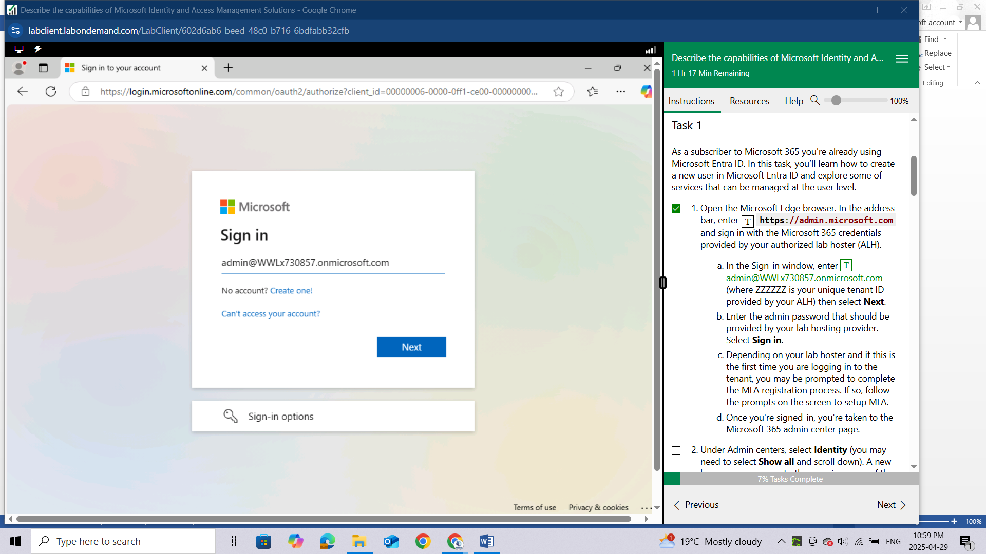

Enter the admin password that should be provided by your lab hosting provider. Select Sign in.

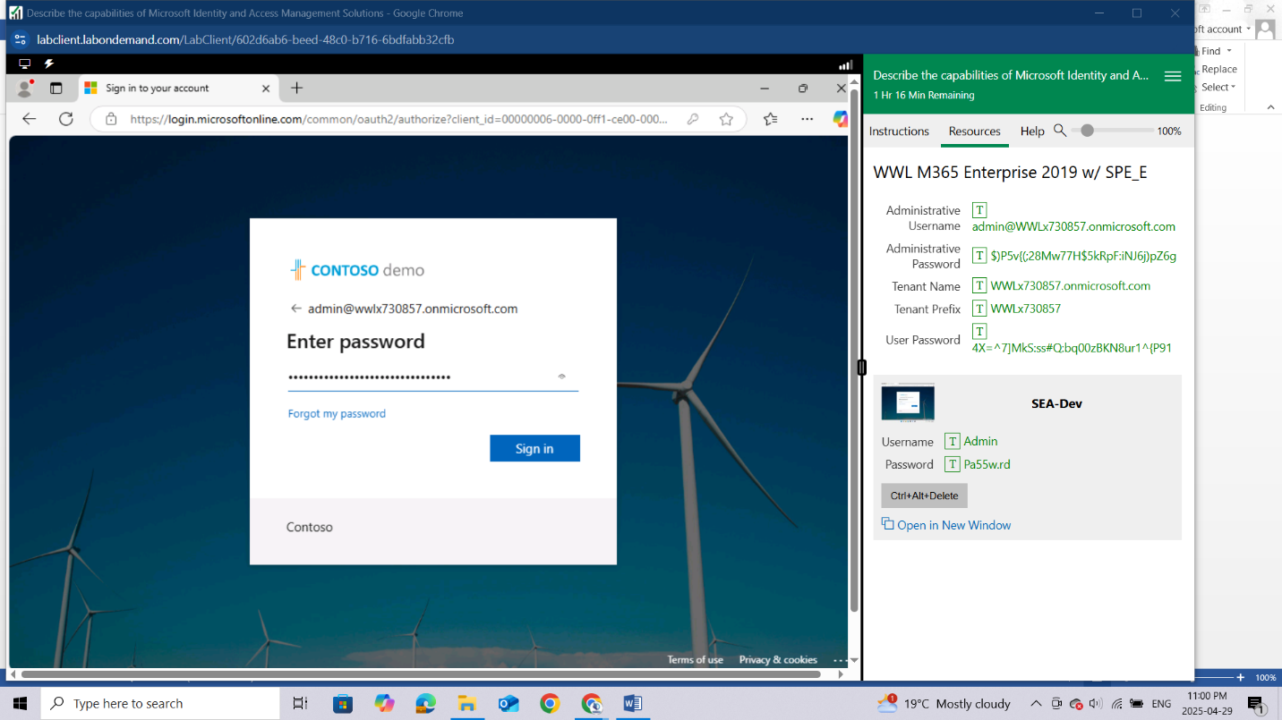

Under Admin centers, select Identity (you may need to select Show all and scroll down).

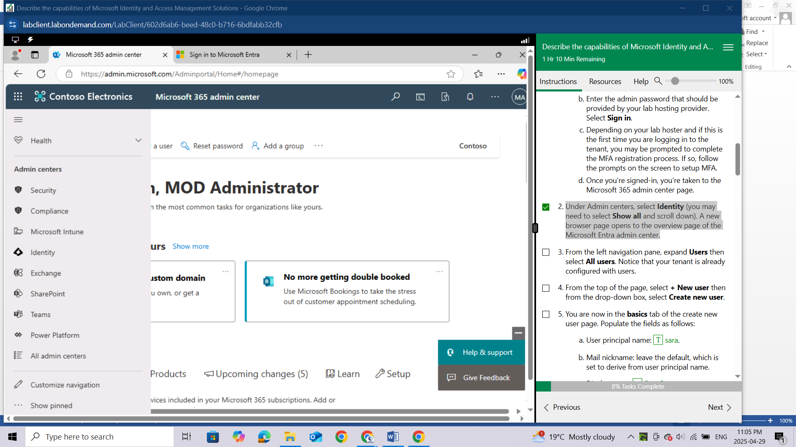

A new browser page opens to the overview page of the Microsoft Entra admin center.

Enable MFA first, using the steps below

Download the Microsoft Authenticator in your phone, then click next

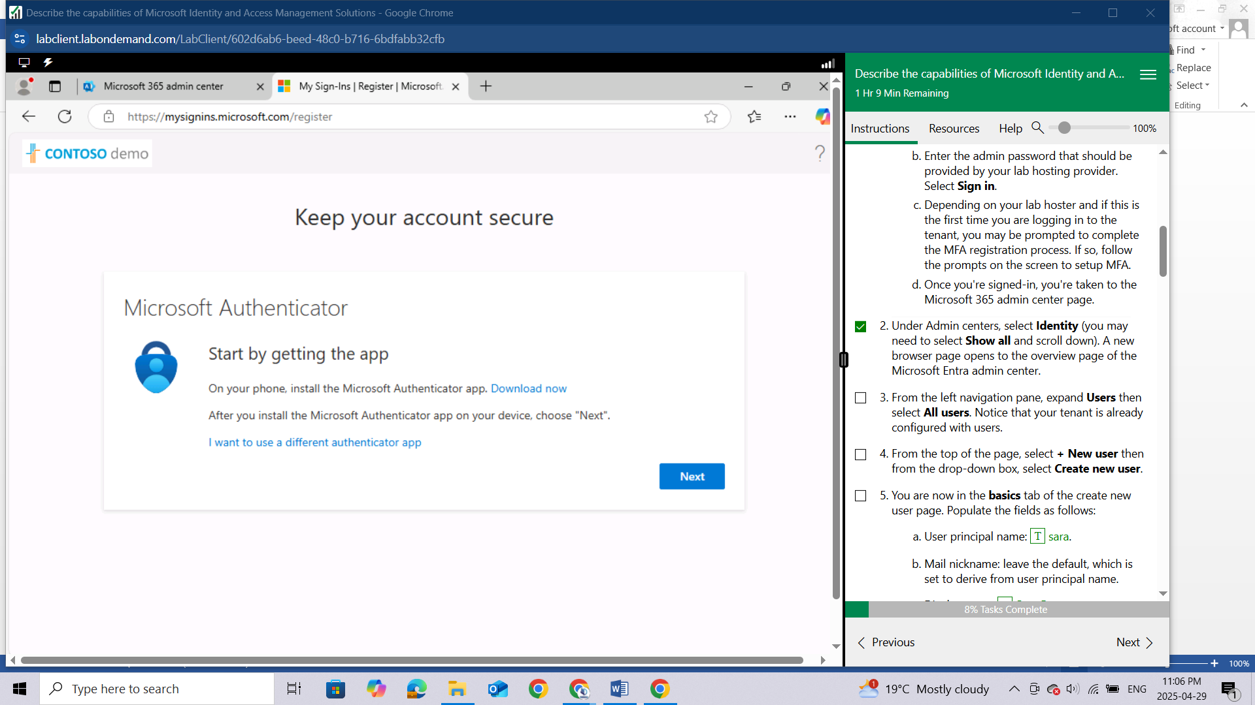

Allow notifications and select Add Work or School account, click on next

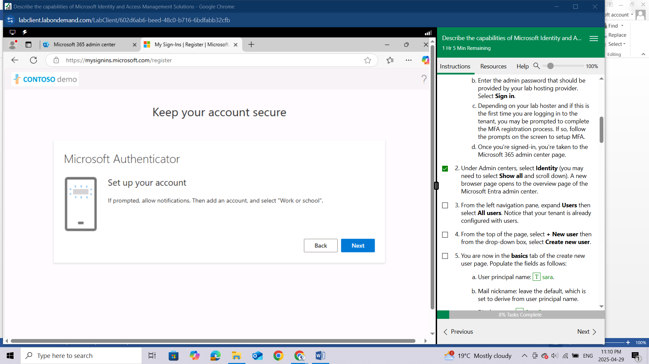

Scan the QR code to connect

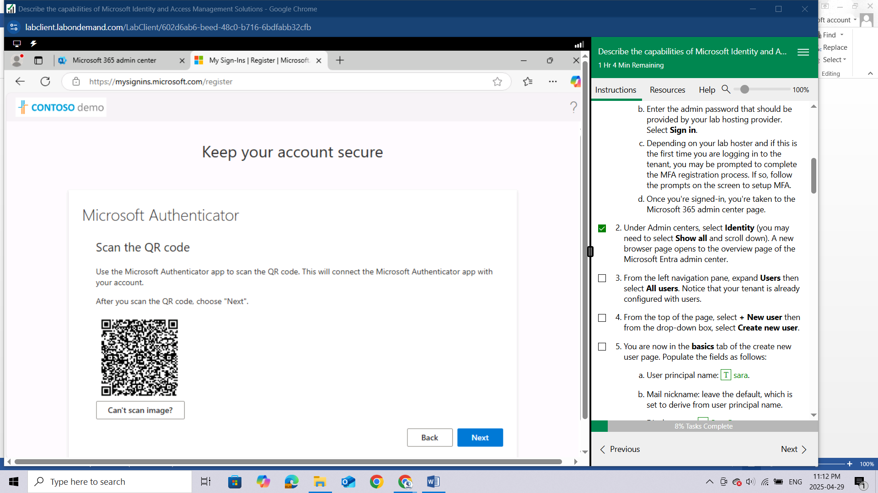

After enabling, It will send notification to allow sign in and if code is correct it will approve

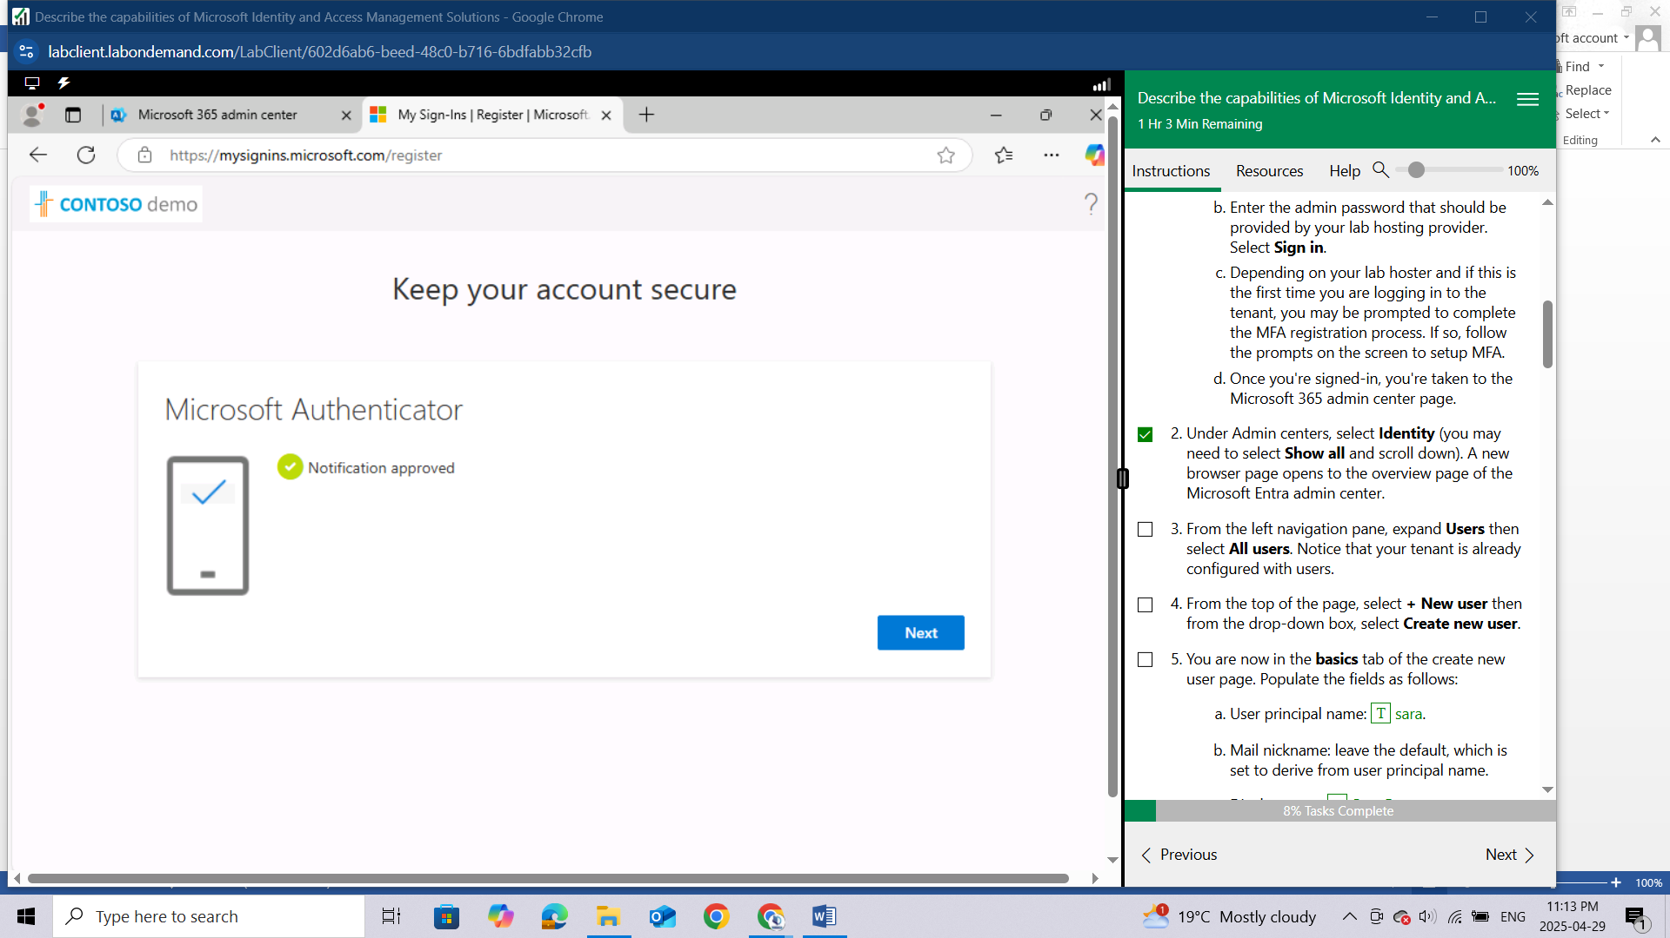

You have successfully enabled MFA

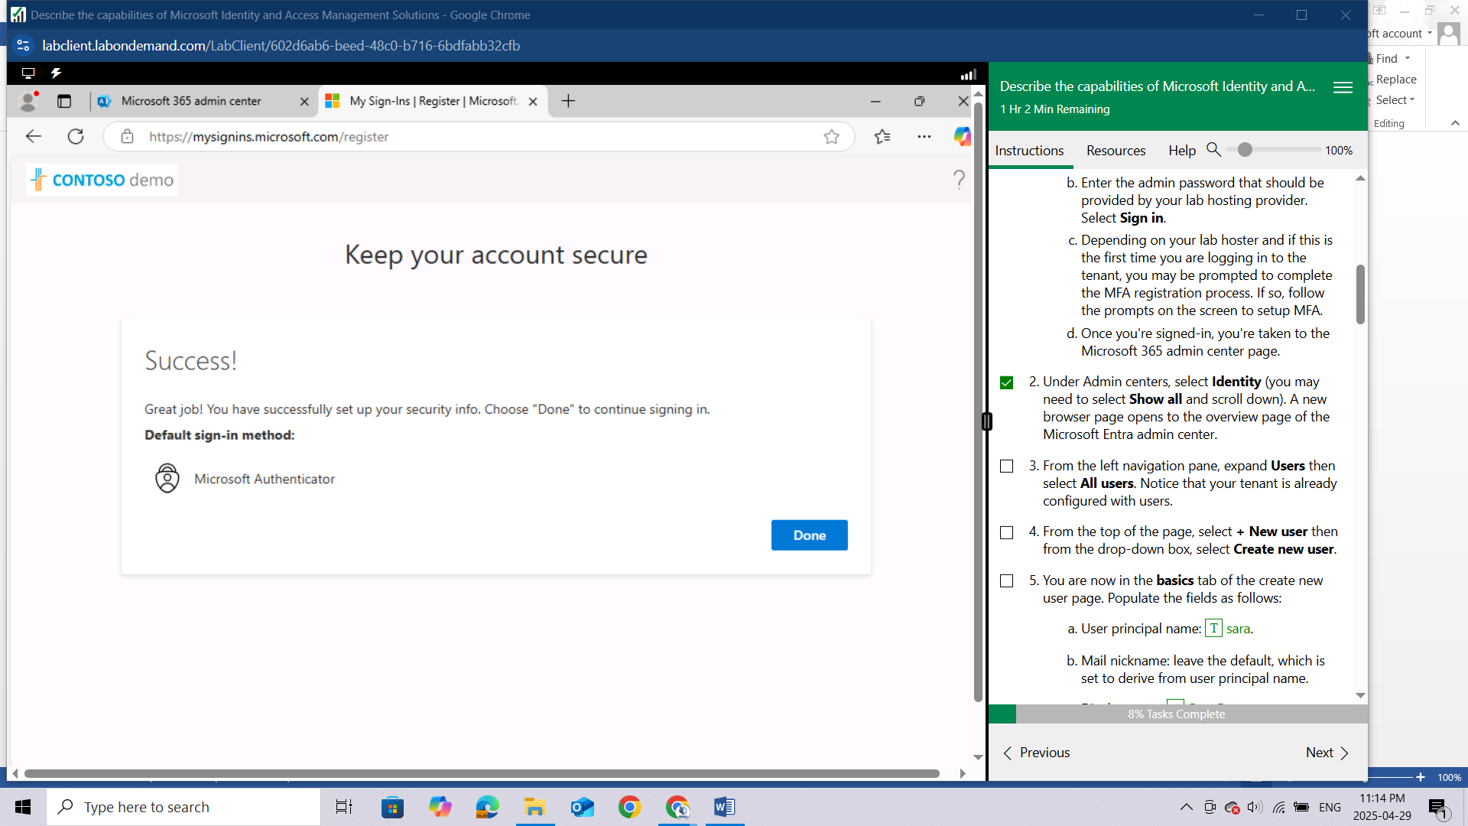

From the left navigation pane, expand **Users** then select **All users.** Notice that your tenant is already configured with users. In this case we have 33 Users already

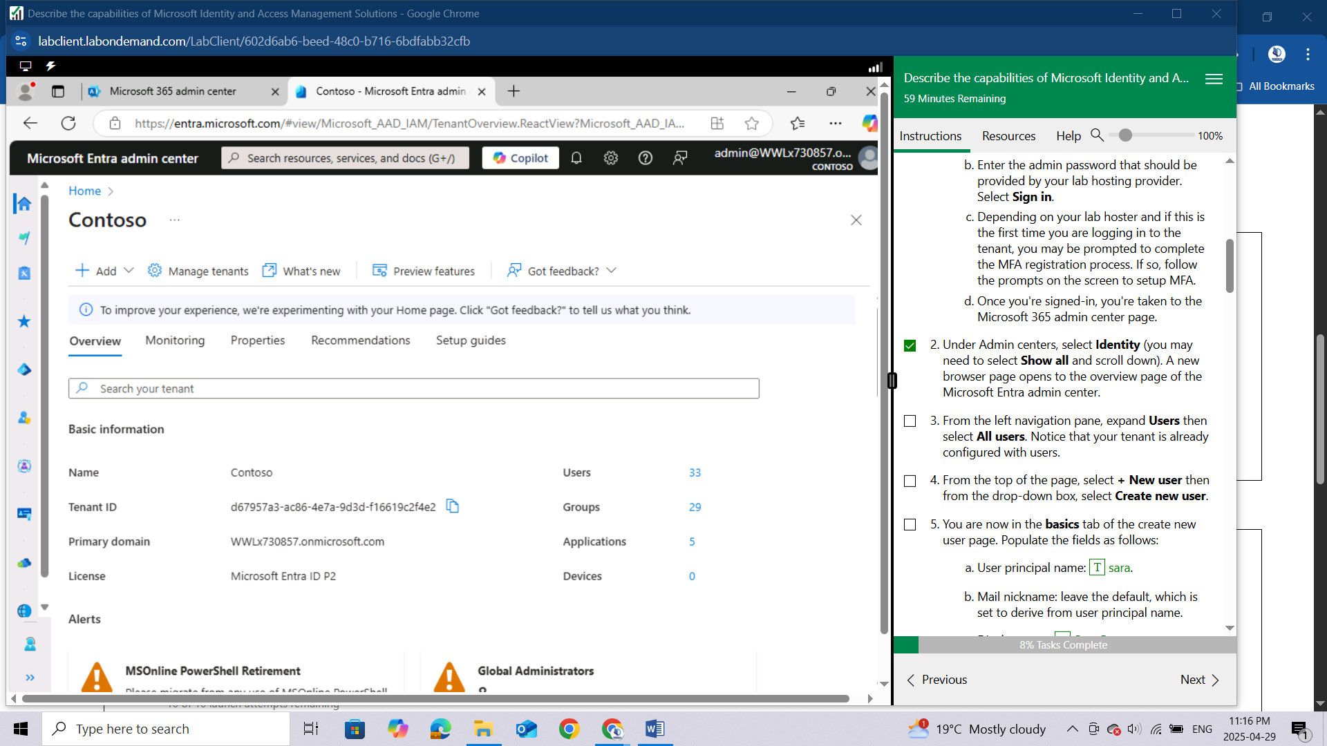

From the top of the page, select **Add** then from the drop-down box**,** select **user** then select **Create new user**.

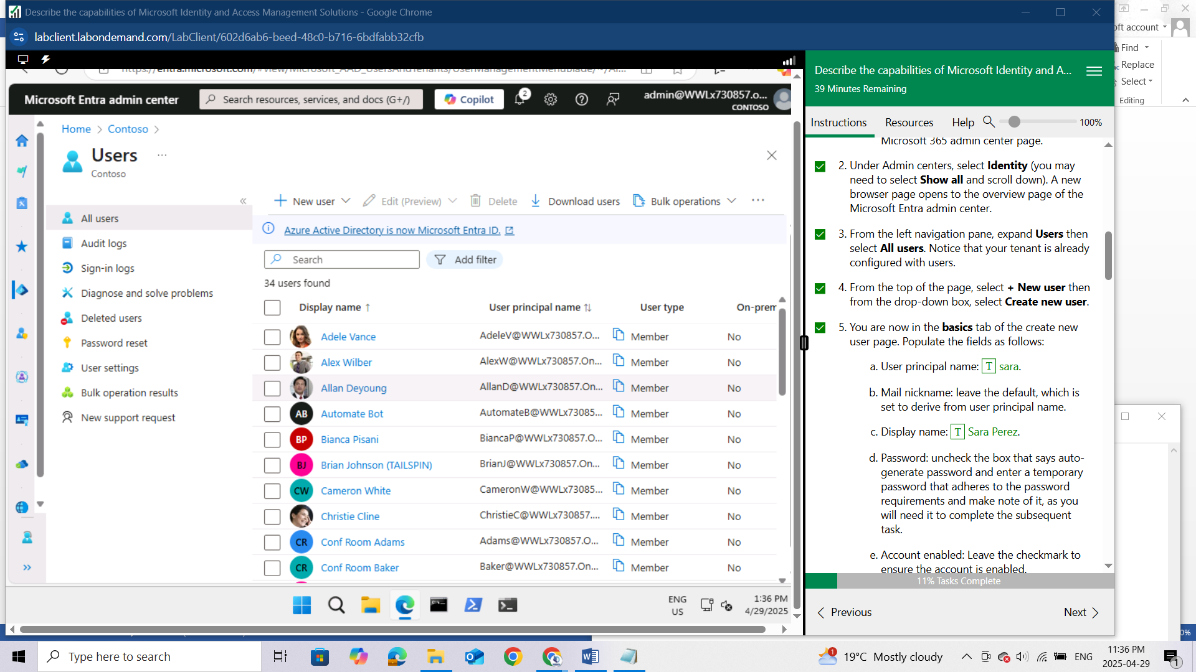

You are now in the **basics** tab of the create new user page. Populate the fields as follows:

* 1. User principal name: sara.
  2. Mail nickname: leave the default, which is set to derive from user principal name.
  3. Display name: Sara Perez.
  4. Password: uncheck the box that says auto-generate password and enter a temporary password that adheres to the password requirements and make note of it, as you will need it to complete the subsequent task.
  5. Account enabled: Leave the checkmark to ensure the account is enabled.
  6. At the bottom of the page, select **Next: Properties**.

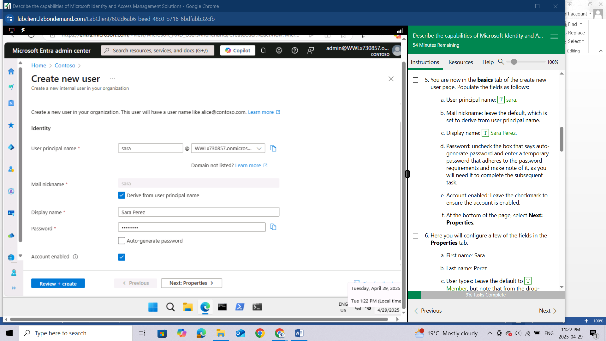

Here you will configure a few of the fields in the **Properties** tab.

1. First name: Sara
2. Last name: Perez
3. User types: Leave the default to Member, but note that from the drop-down you have the option to select guest.

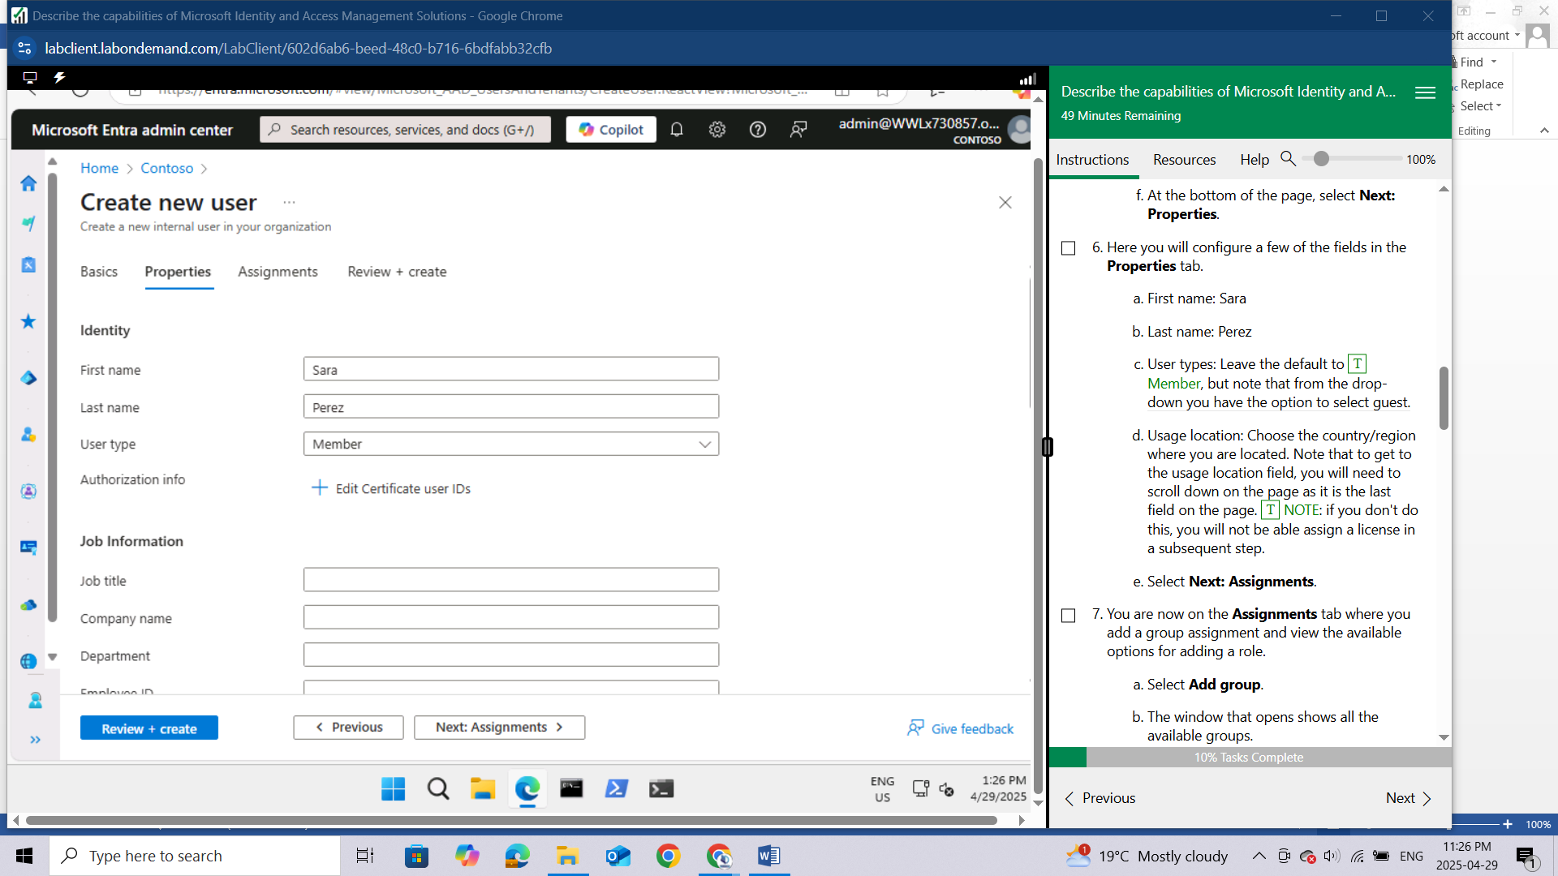

Usage location: Choose the country/region where you are located. Note that to get to the usage location field, you will need to scroll down on the page as it is the last field on the page. NOTE: if you don't do this, you will not be able assign a license in a subsequent step.

Select **Next: Assignments**.

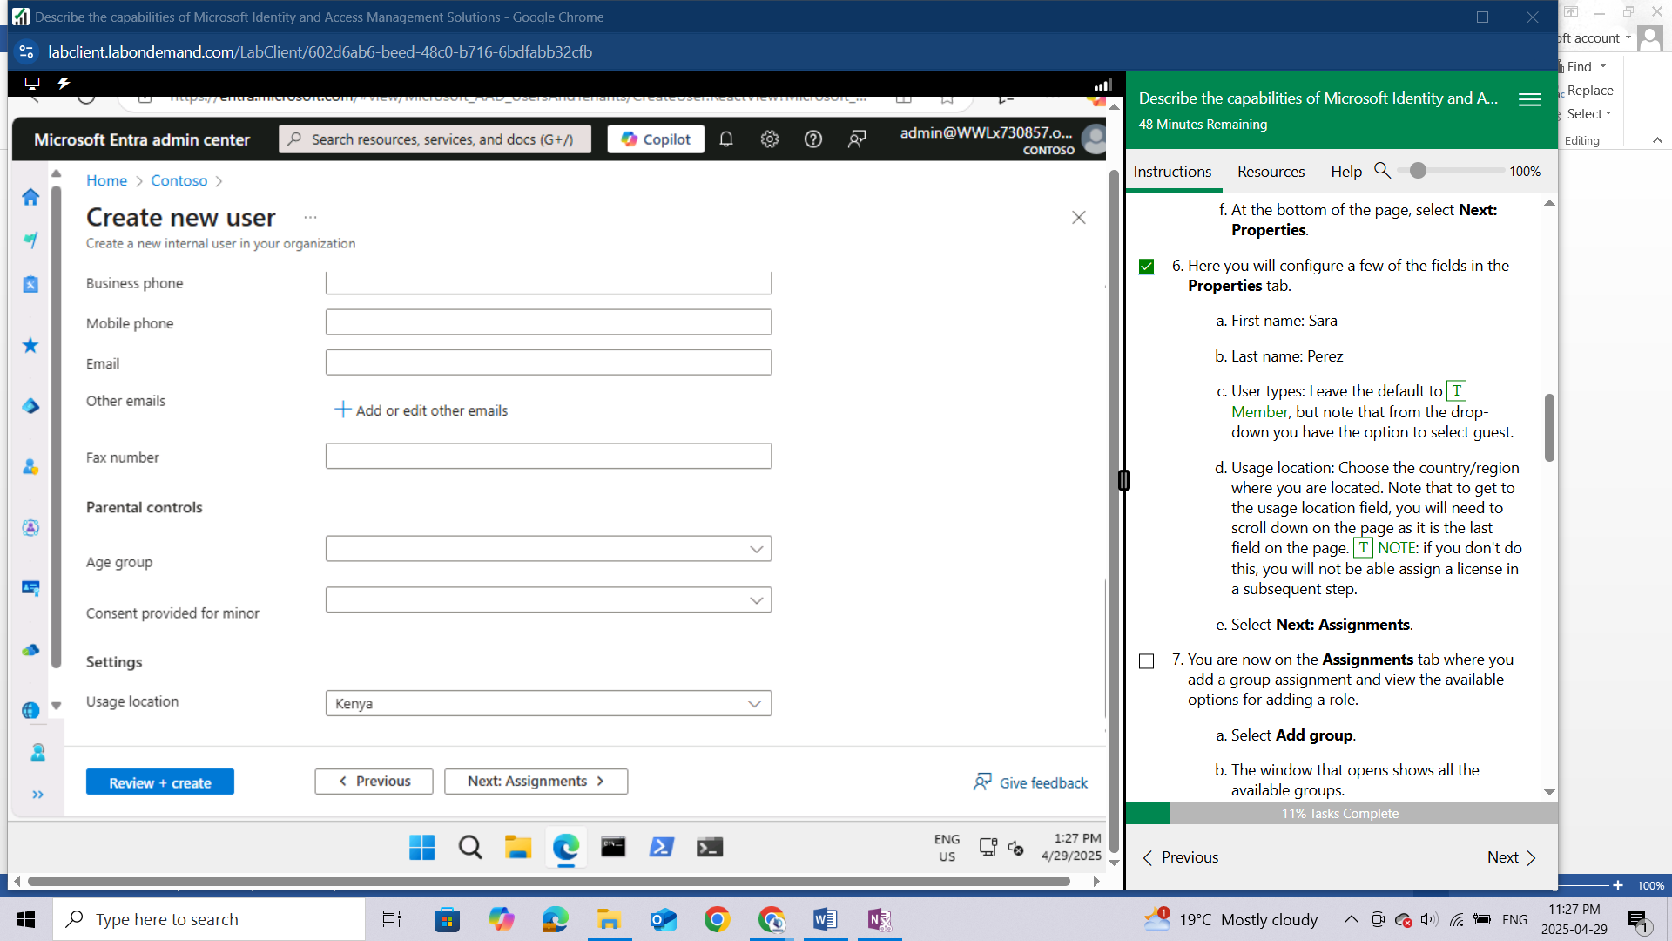

You are now on the **Assignments** tab where you add a group assignment and view the available options for adding a role.

1. Select **Add group**.
2. The window that opens shows all the available groups.
3. Notice the list of available groups. From the list, select **Operations**.

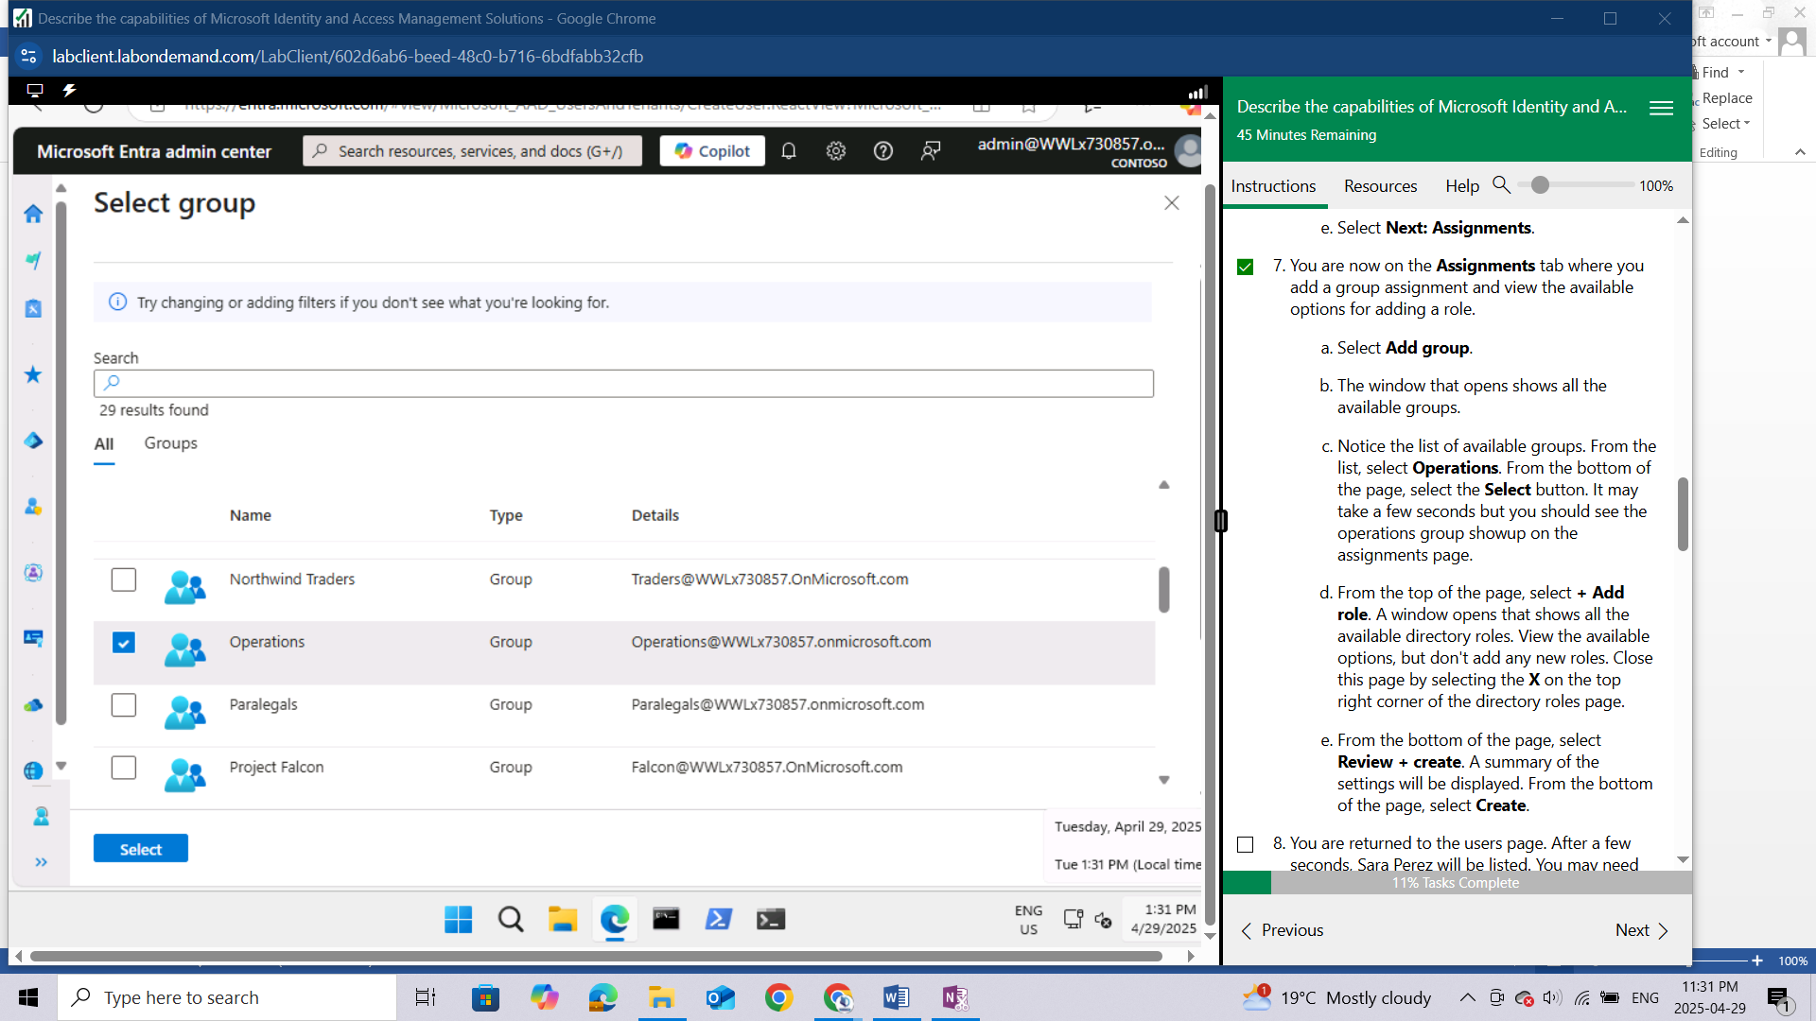

From the bottom of the page, select the **Select** button. It may take a few seconds but you should see the operations group showup on the assignments page.

1. From the top of the page, select **+ Add role**. A window opens that shows all the available directory roles. View the available options, but don't add any new roles. Close this page by selecting the **X** on the top right corner of the directory roles page.

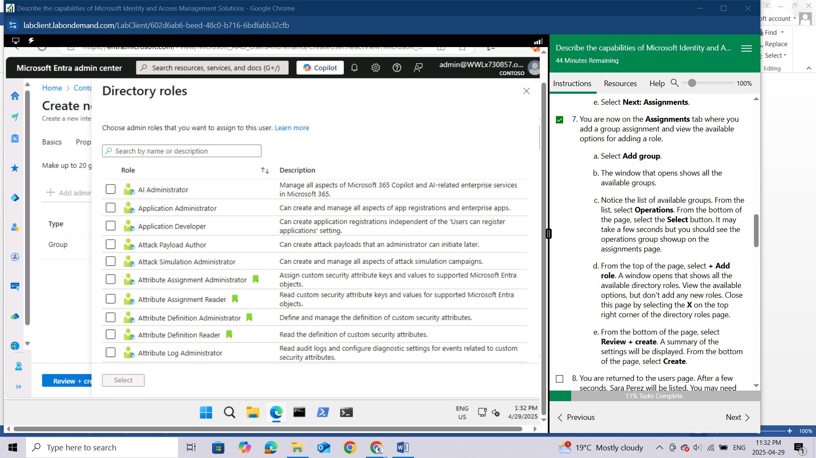

1. From the bottom of the page, select **Review + create**. A summary of the settings will be displayed. From the bottom of the page, select **Create**.

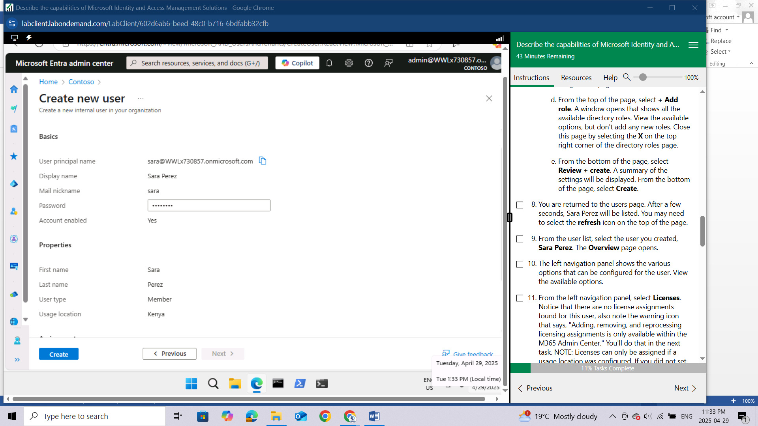

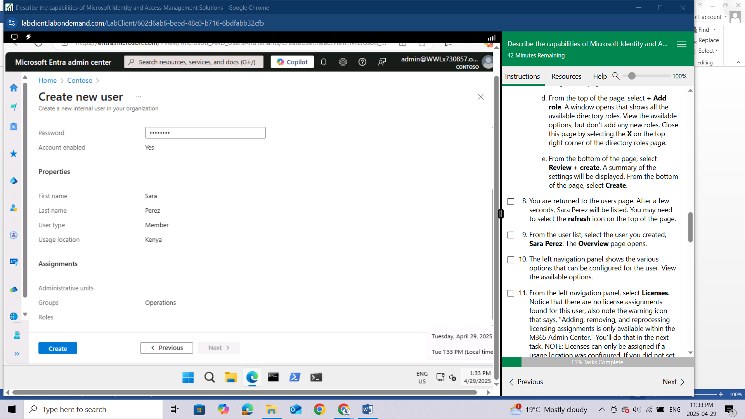

You are returned to the users page. After a few seconds, Sara Perez will be listed. You may need to select the **refresh** icon on the top of the page.

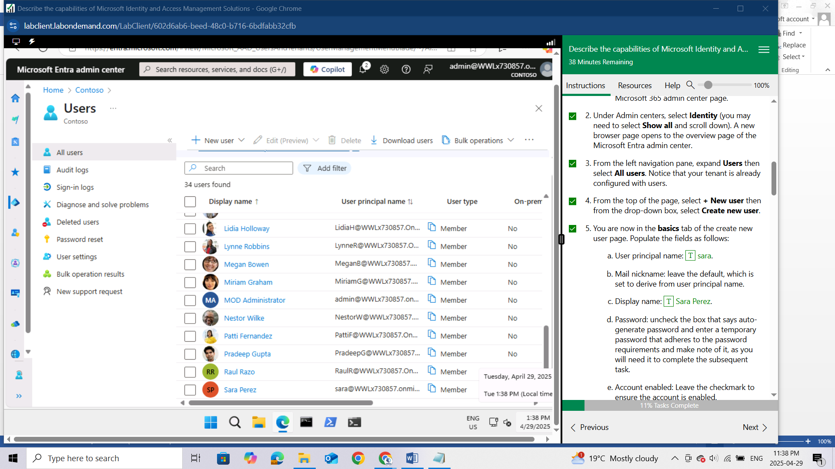

From the user list, select the user you created, **Sara Perez**. The Overview page opens.

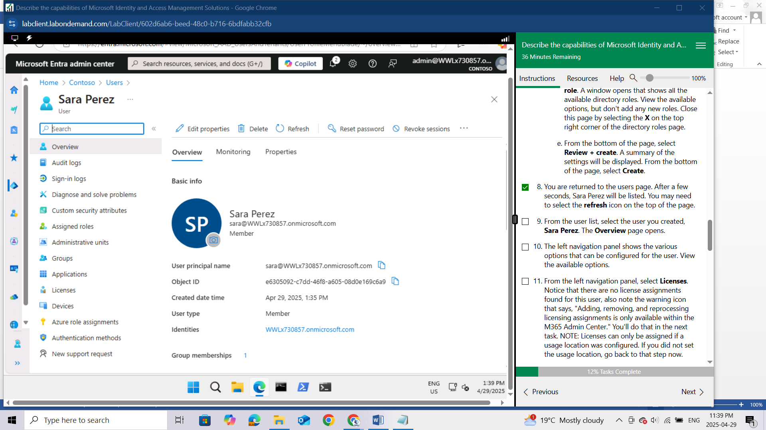

The left navigation panel shows the various options that can be configured for the user. View the available options.

From the left navigation panel, select **Licenses**. Notice that there are no license assignments found for this user, also note the warning icon that says, "Adding, removing, and reprocessing licensing assignments is only available within the M365 Admin Center." You'll do that in the next task. NOTE: Licenses can only be assigned if a usage location was configured. If you did not set the usage location, go back to that step now.

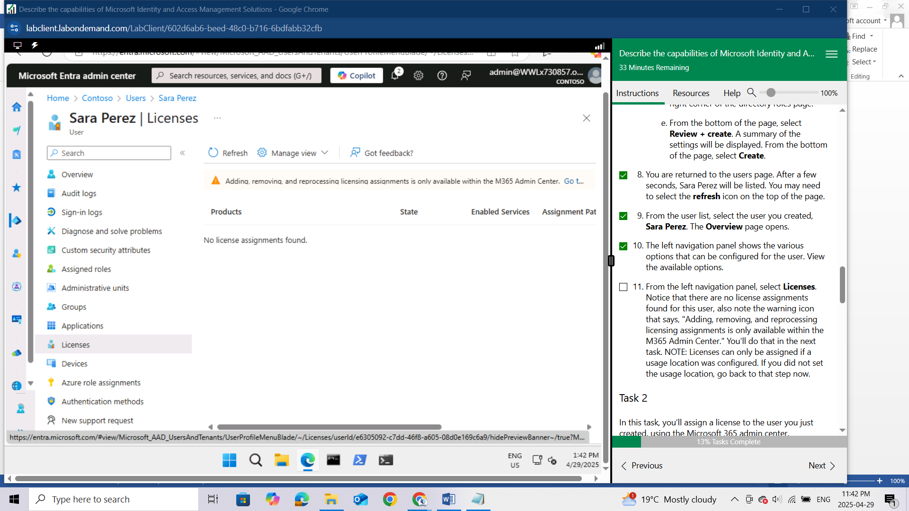

### Task 2

In this task, you’ll assign a license to the user you just created, using the Microsoft 365 admin center.

Open the browser tab **Home - Microsoft 365 admin center**.

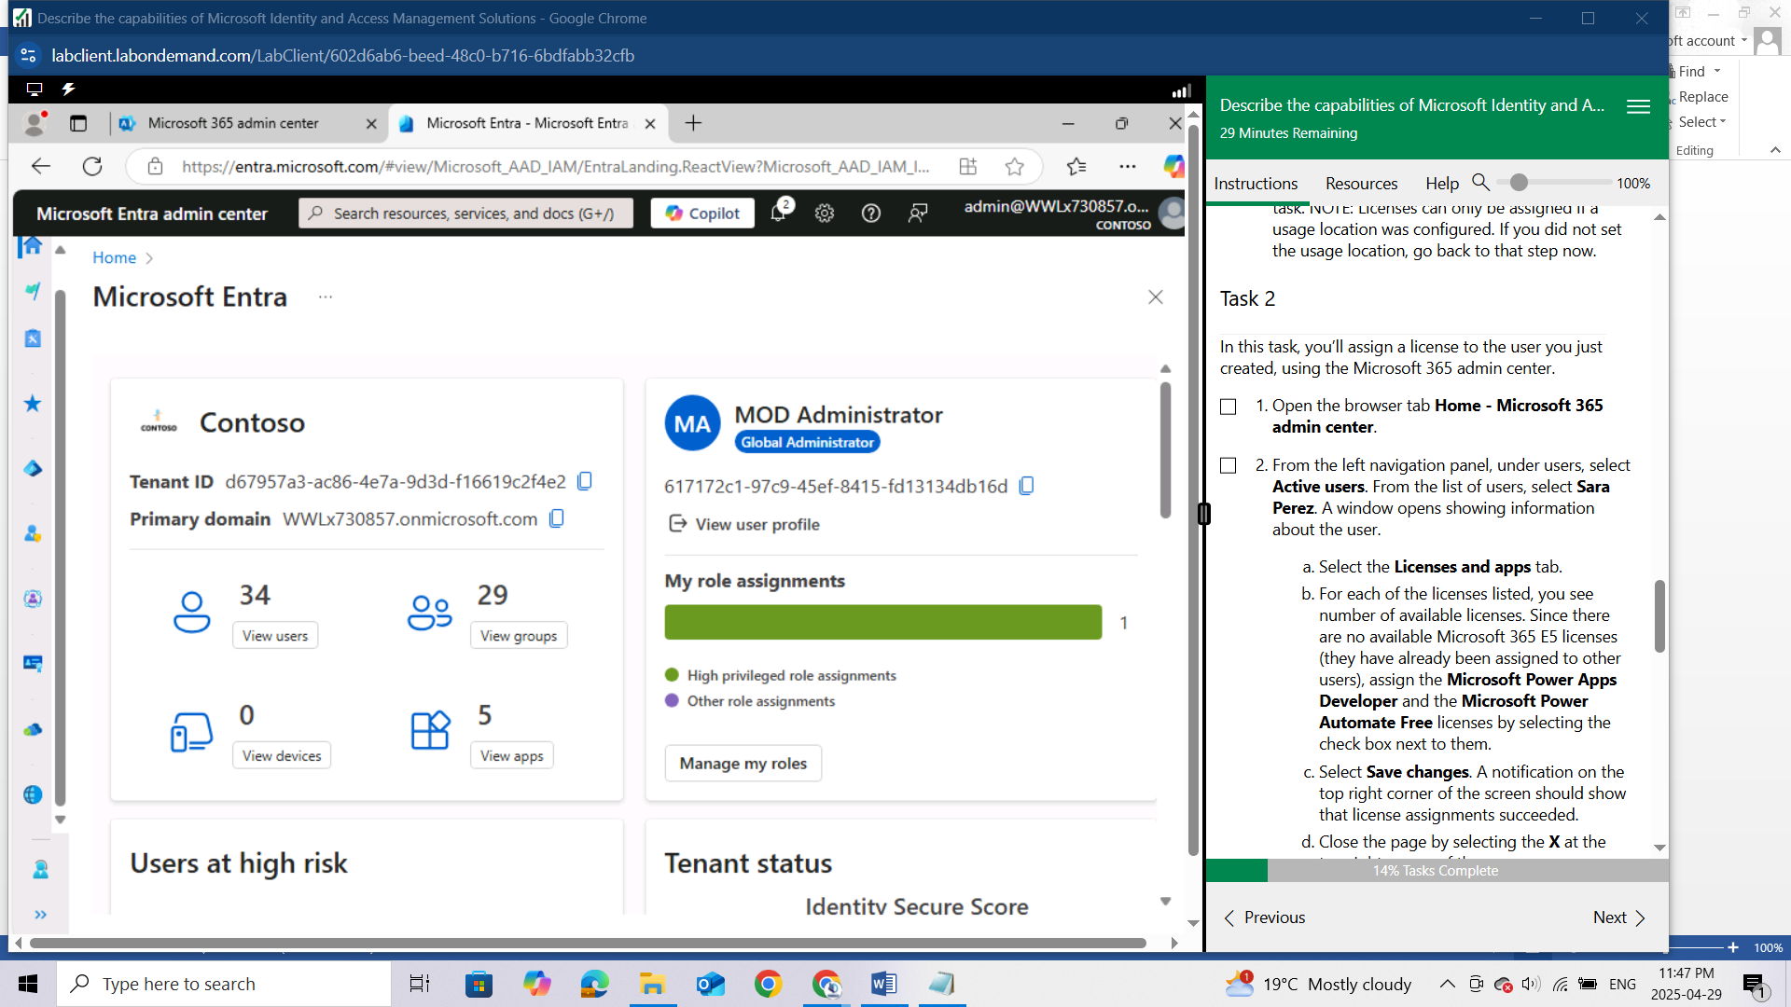

From the left navigation panel, under users, select **Active users**. From the list of users, select **Sara Perez**.

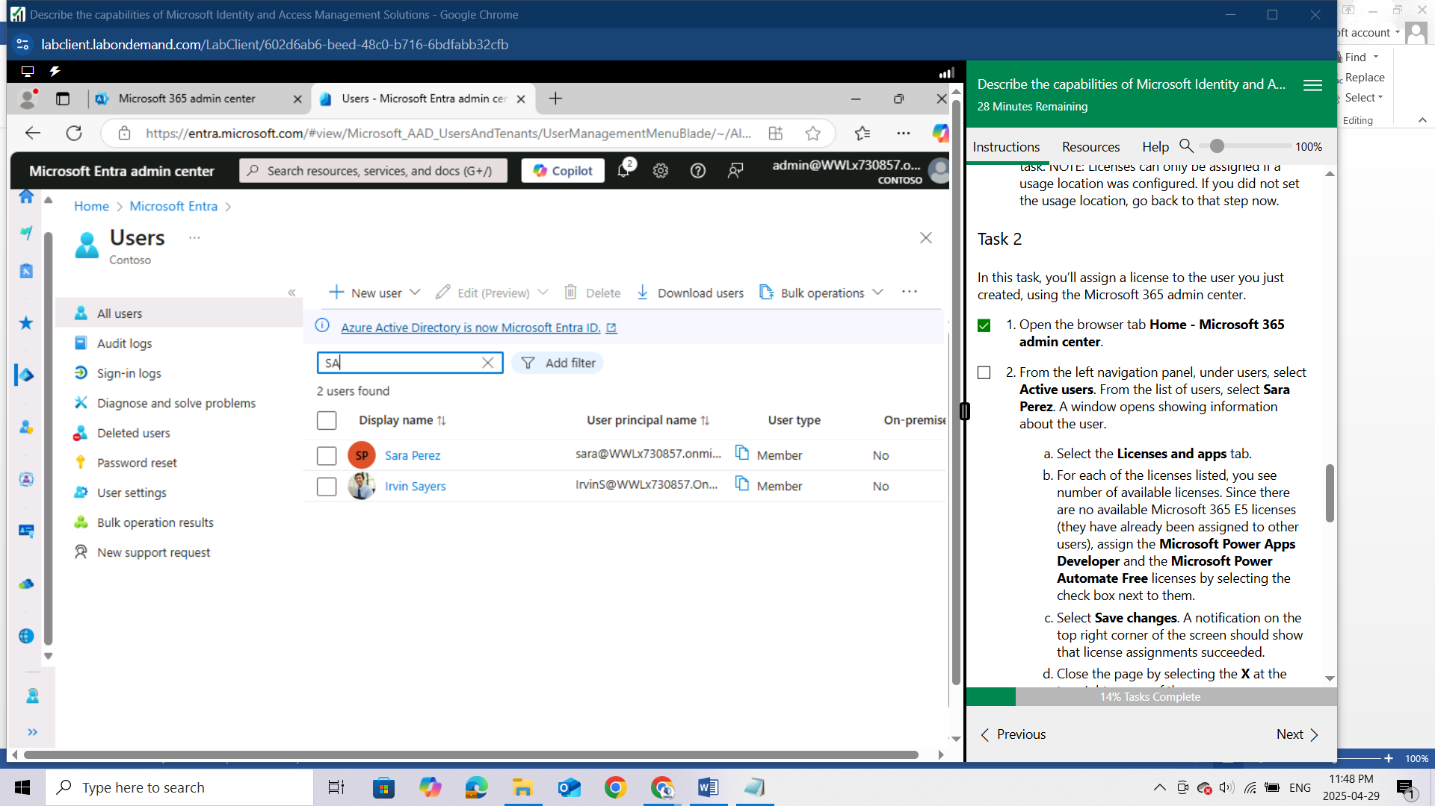

A window opens showing information about the user

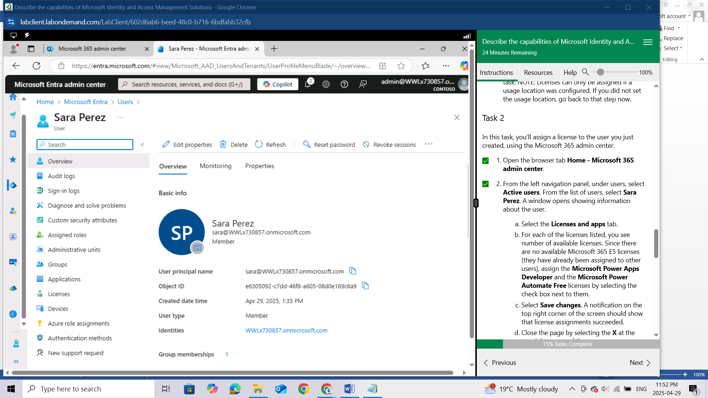

1. Select the **Licenses and apps** tab.

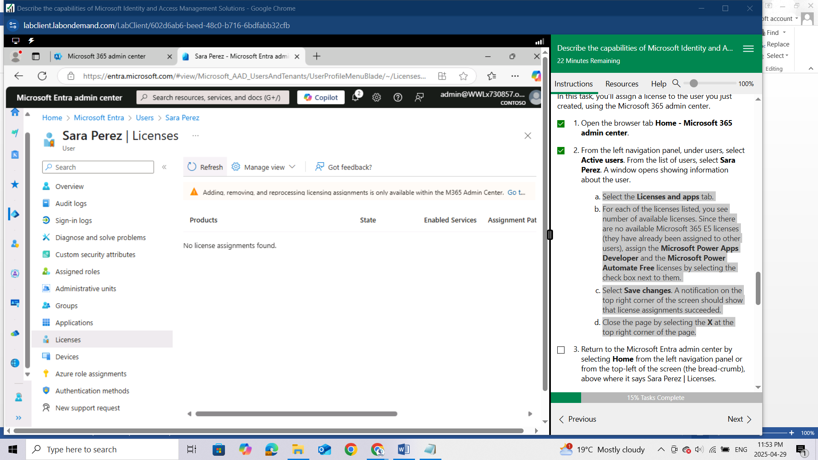

1. For each of the licenses listed, you see number of available licenses. Since there are no available Microsoft 365 E5 licenses (they have already been assigned to other users

To navigate to the licences click on Go to… link located on the “**Adding,removing and reprocessing warning”**



It opens a new page showing available licenses

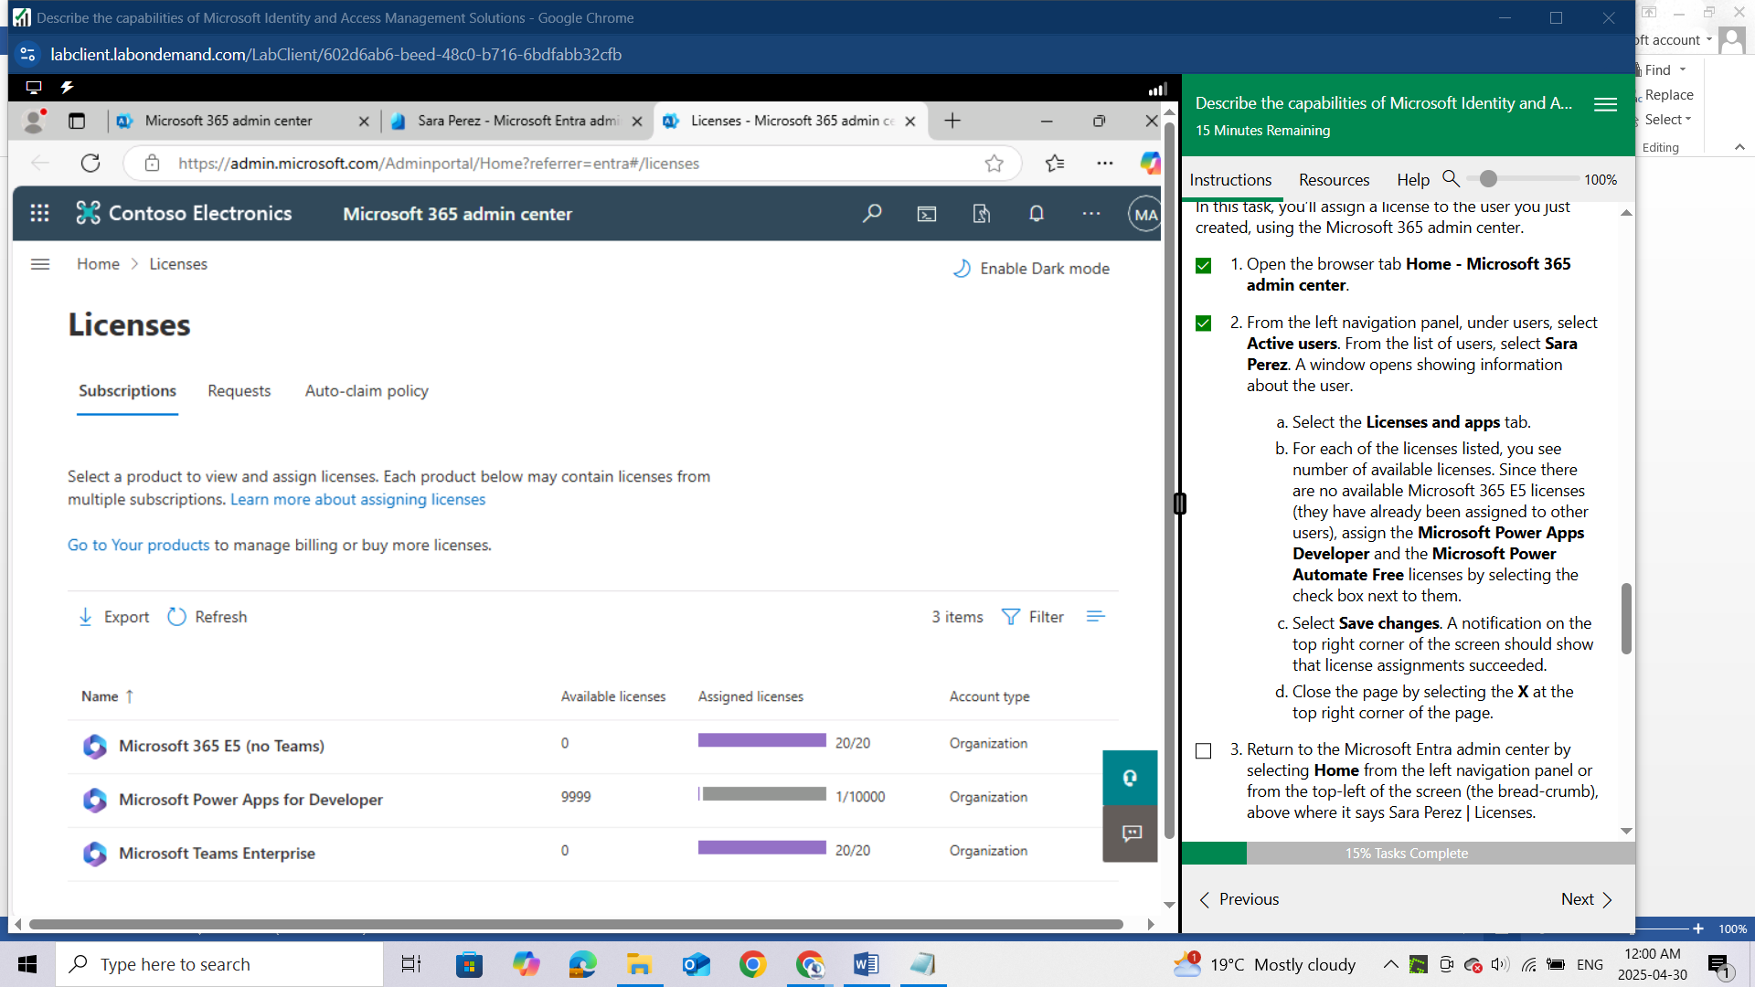

assign the **Microsoft Power Apps Developer**

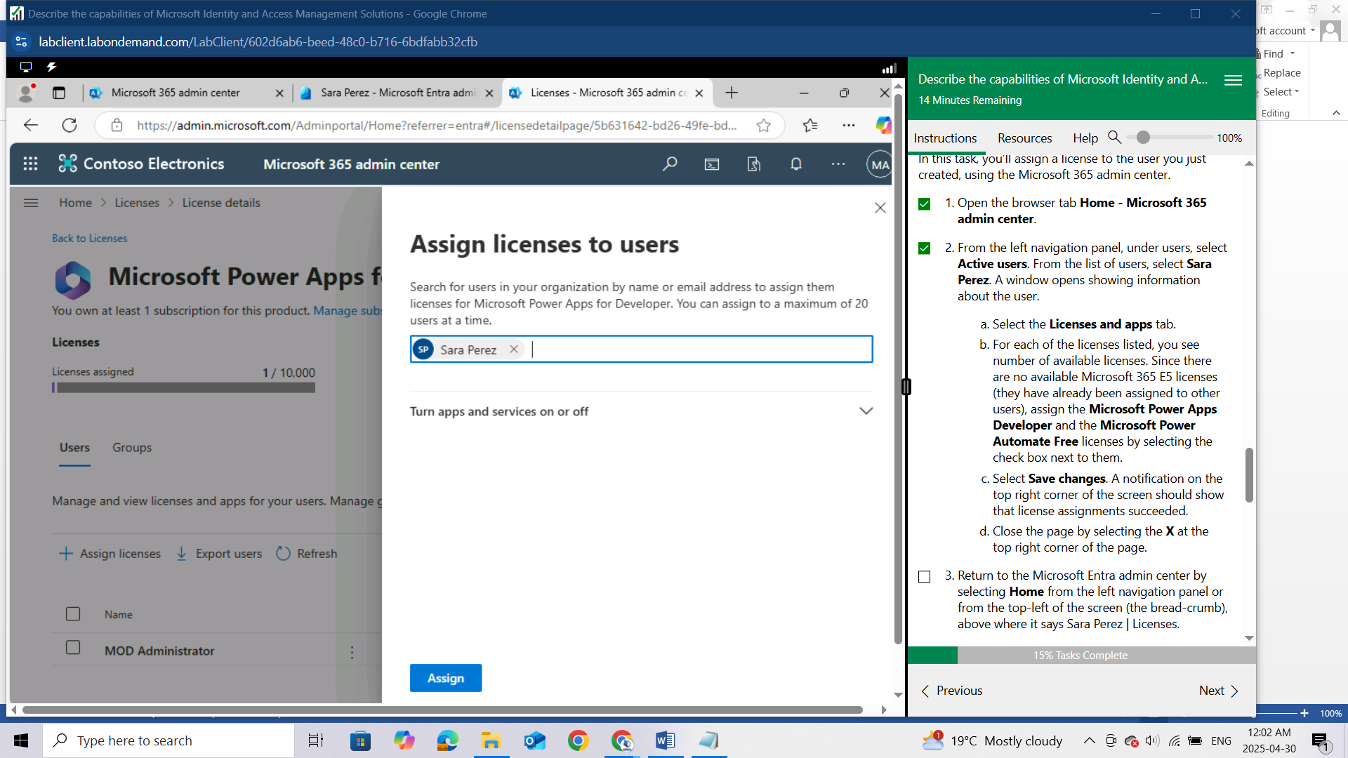

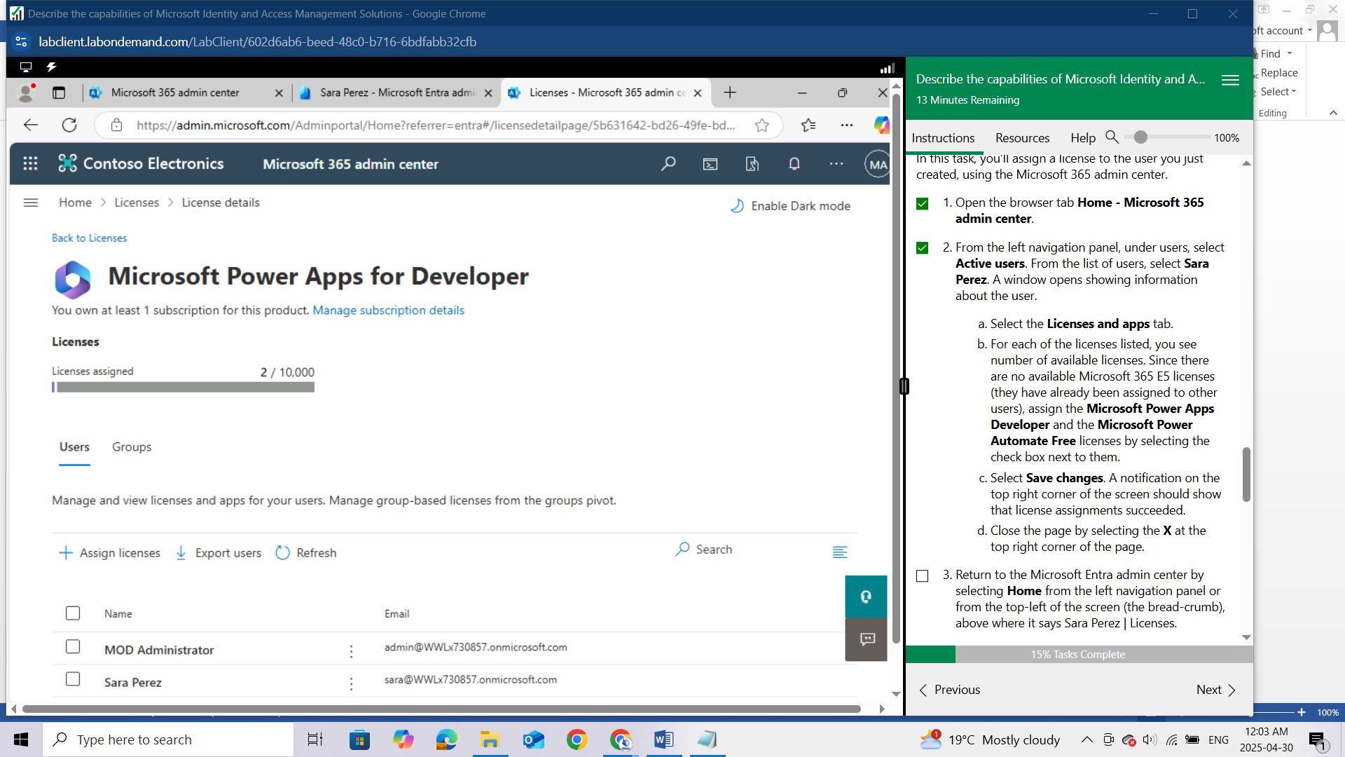

and the **Microsoft Power Automate Free** licenses by selecting the check box next to them.

In my Case the **Microsoft Power Automate Free** is missing

1. Select **Save changes**. A notification on the top right corner of the screen should show that license assignments succeeded.
2. Close the page by selecting the **X** at the top right corner of the page.
3. Return to the Microsoft Entra admin center by selecting **Home** from the left navigation panel or from the top-left of the screen (the bread-crumb), above where it says Sara Perez | Licenses.
4. You have successfully assigned licenses to the user.

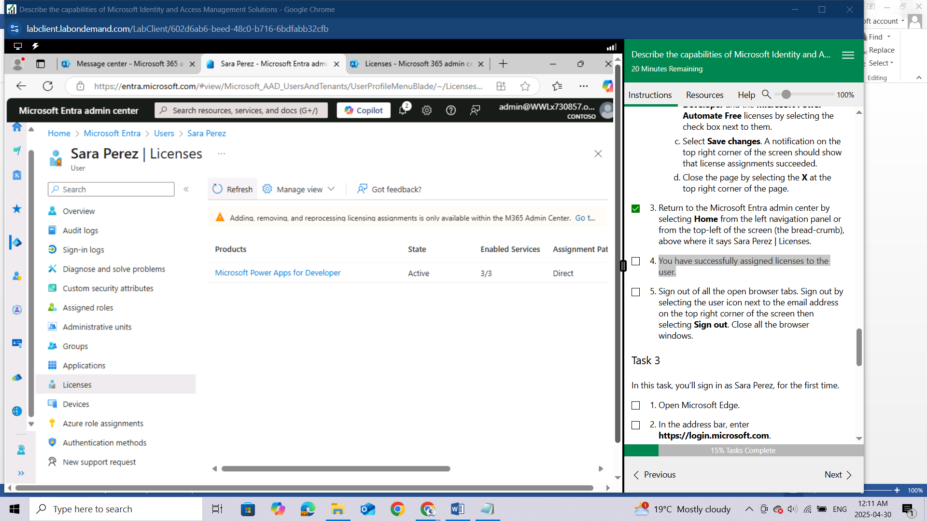

Sign out of all the open browser tabs. Sign out by selecting the user icon next to the email address on the top right corner of the screen then selecting Sign out. Close all the browser windows.

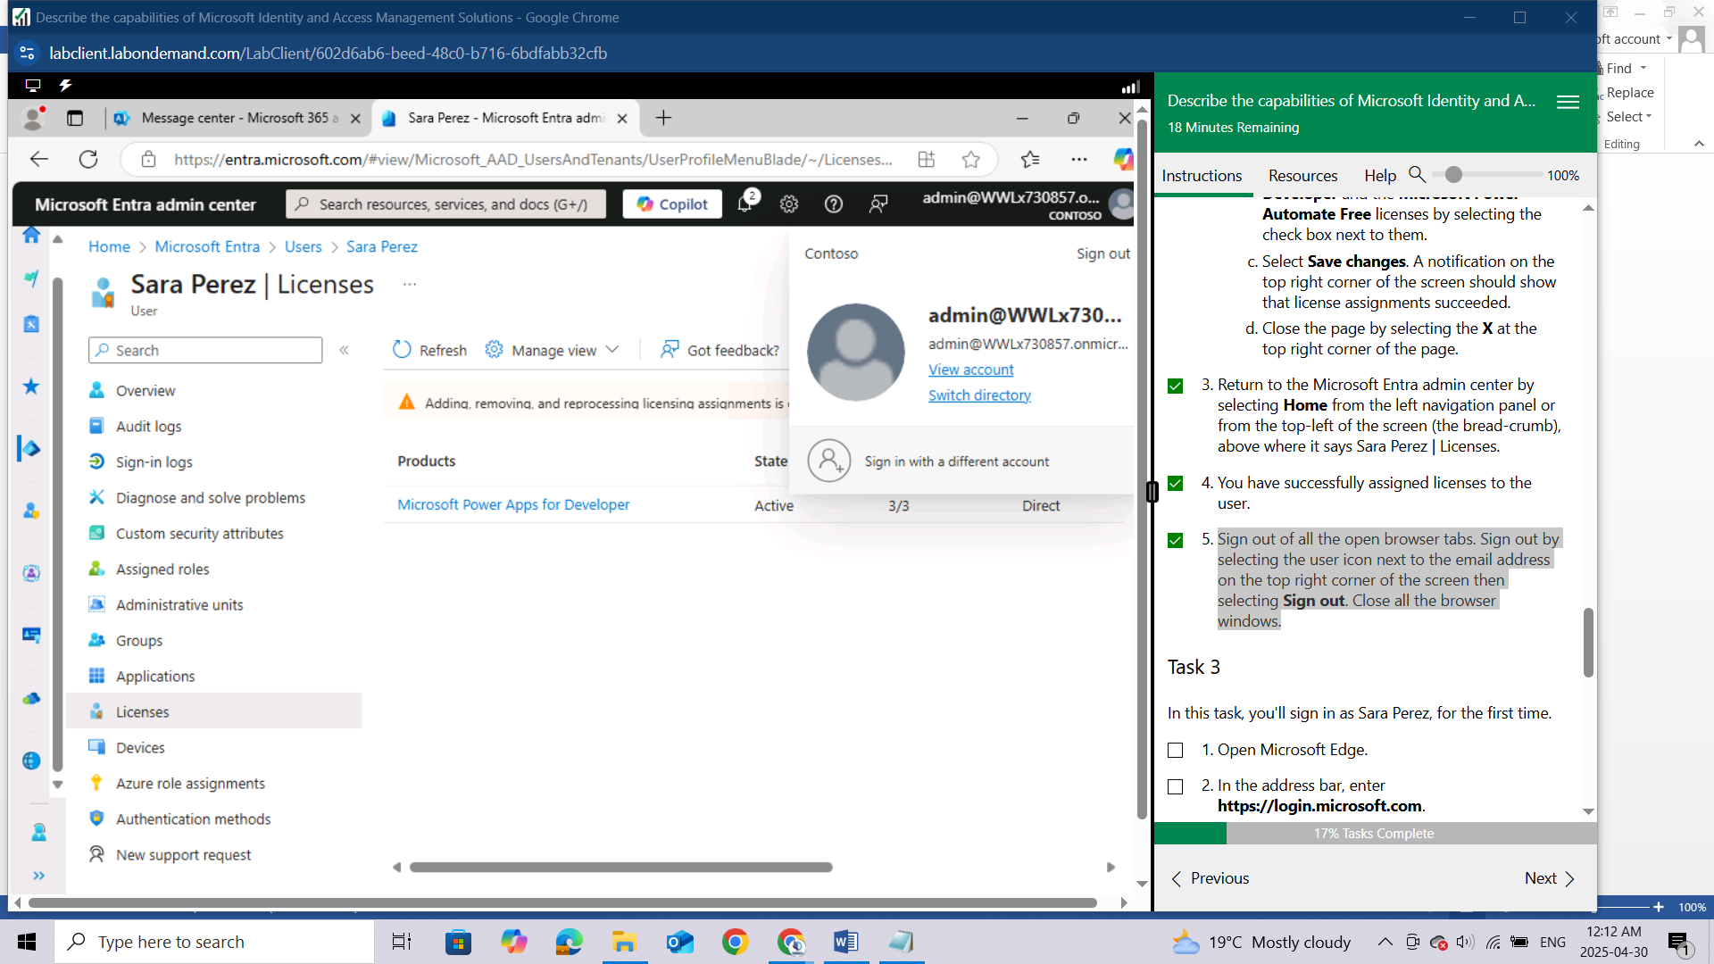

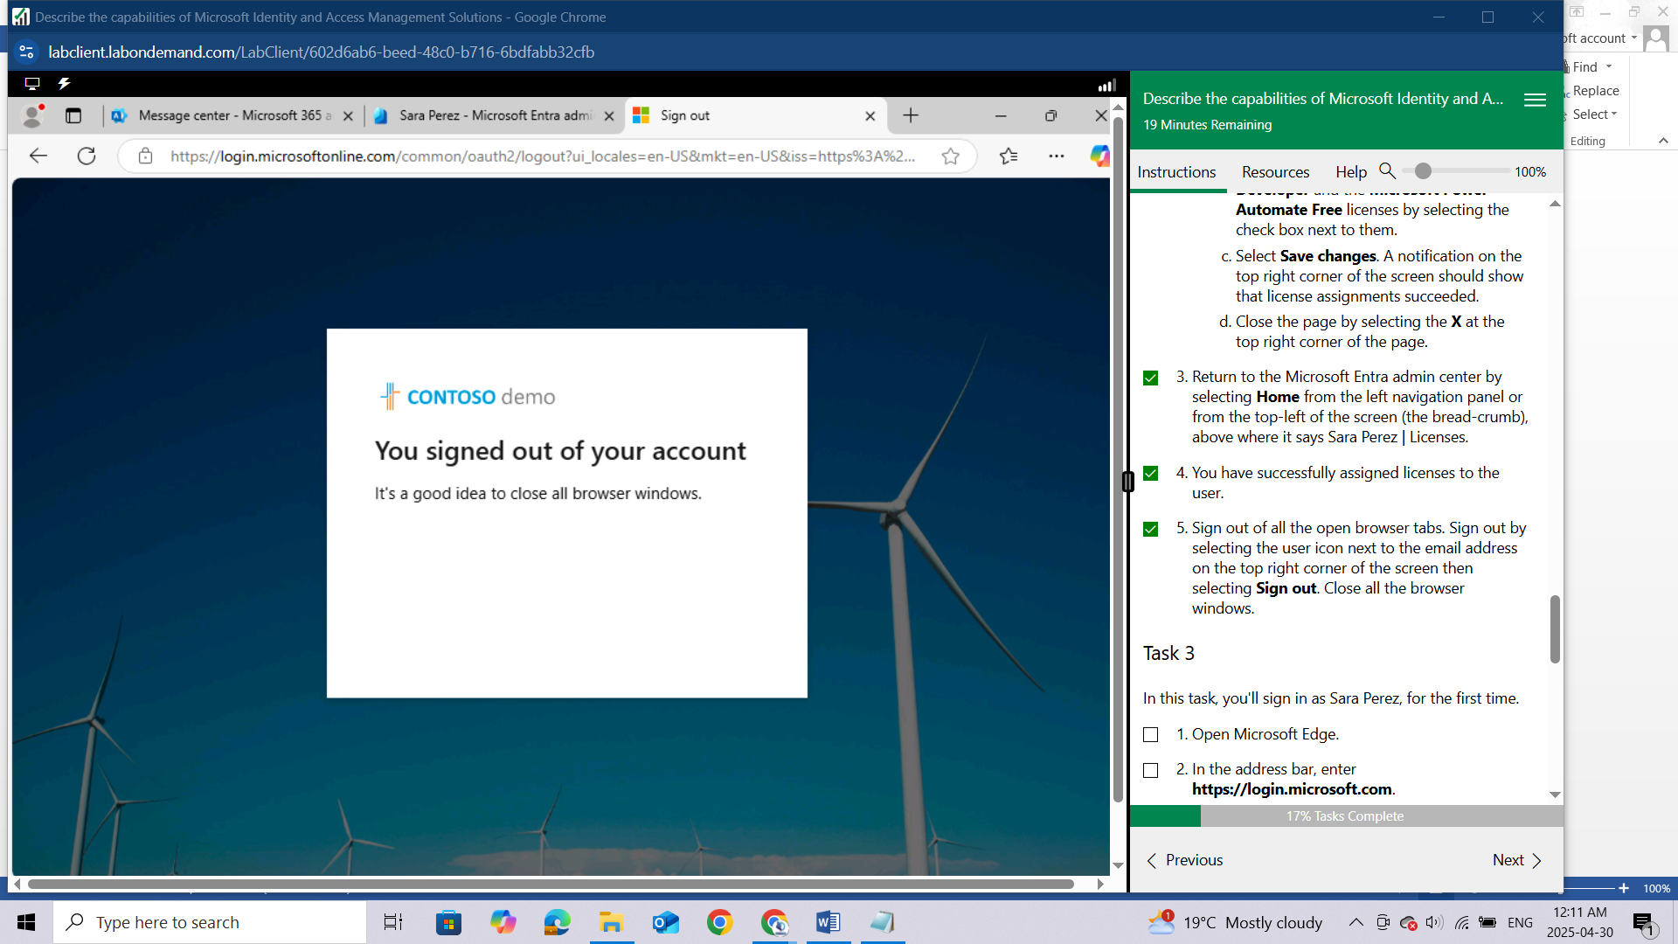

### Task 3

In this task, you'll sign in as Sara Perez, for the first time.

1. Open Microsoft Edge.

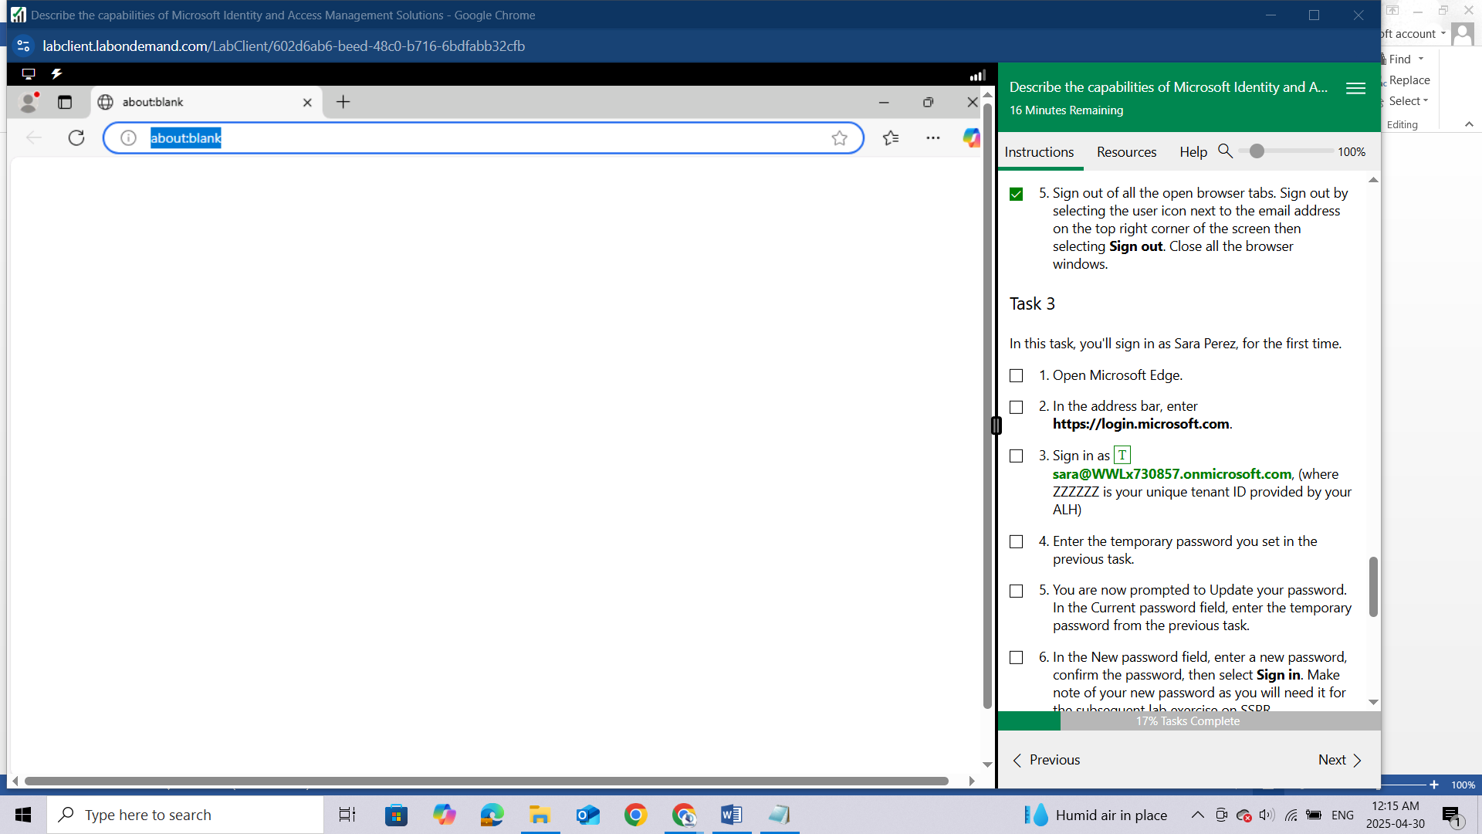

1. In the address bar, enter <https://login.microsoft.com>.

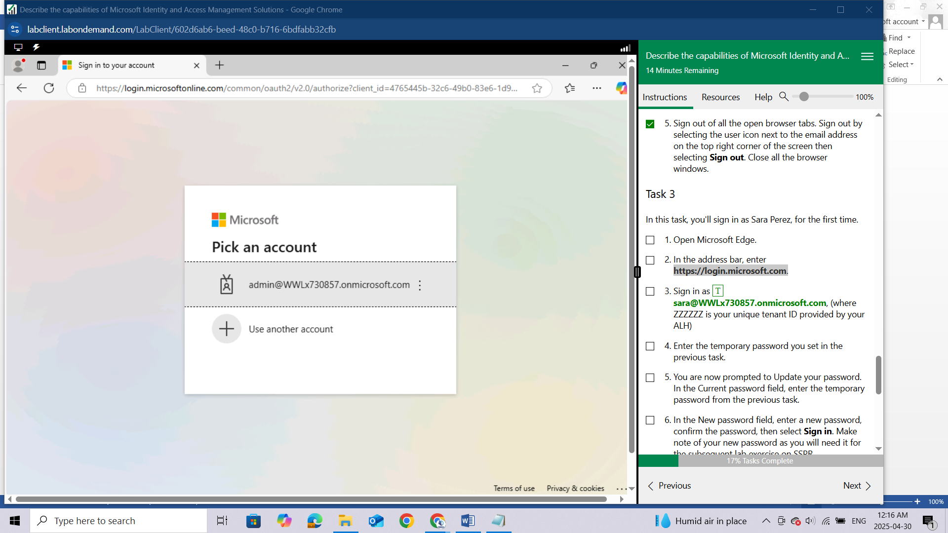

Sign in as sara @WWLxZZZZZ.onmicrosoft.com, (where ZZZZZZ is your unique tenant ID provided by your ALH)

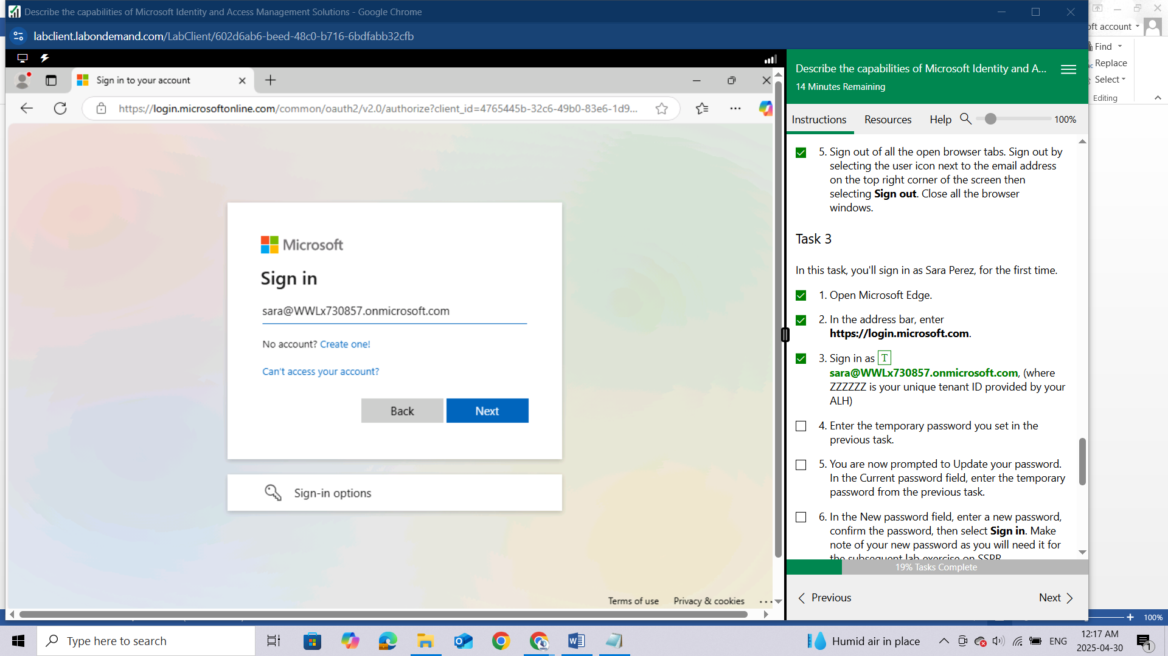

Enter the temporary password you set in the previous task.

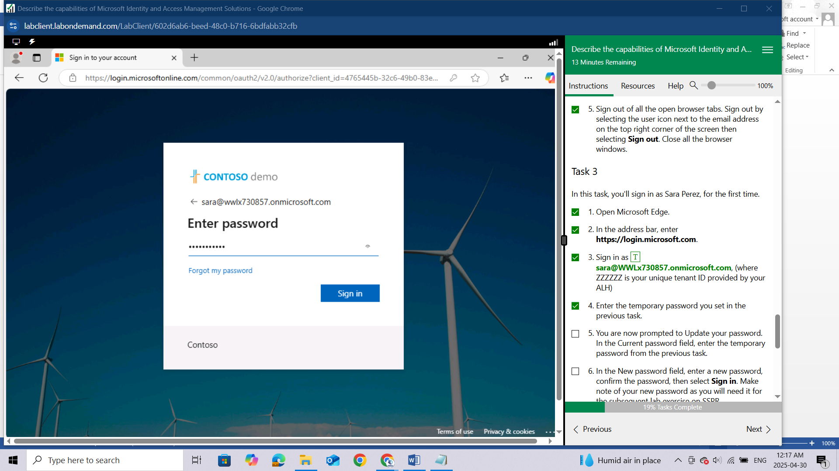

You are now prompted to Update your password. In the Current password field, enter the temporary password from the previous task.

In the New password field, enter a new password, confirm the password, then select Sign in. Make note of your new password as you will need it for the subsequent lab exercise on SSPR.

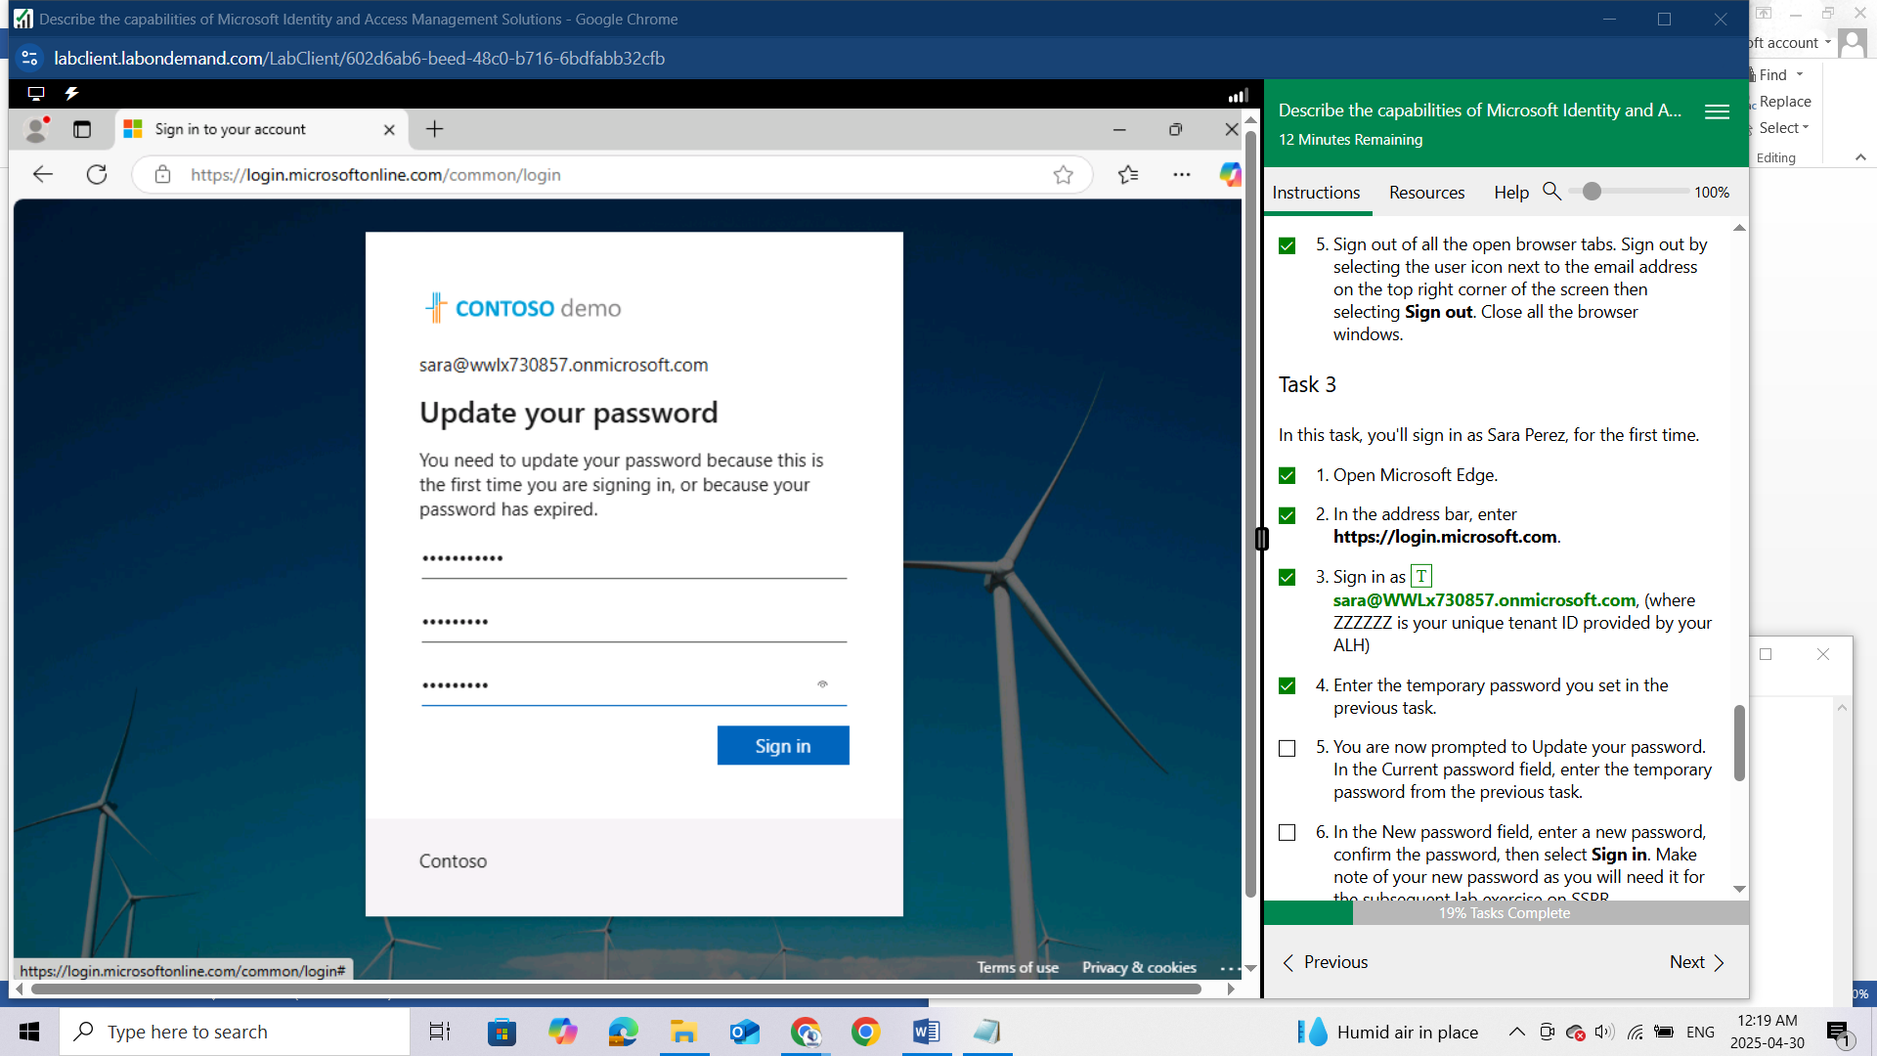Since this is the first time you are logging in as Sara Perez, you may be prompted to setup MFA. Follow the prompts on the screen to setup MFA.

You should now be successfully signed-in to Sara's Microsoft account. Note that Sara's licensing that you assigned in the previous task was limited only to Power Automate Free and Power Apps for Developer and did not include E5 licensing.

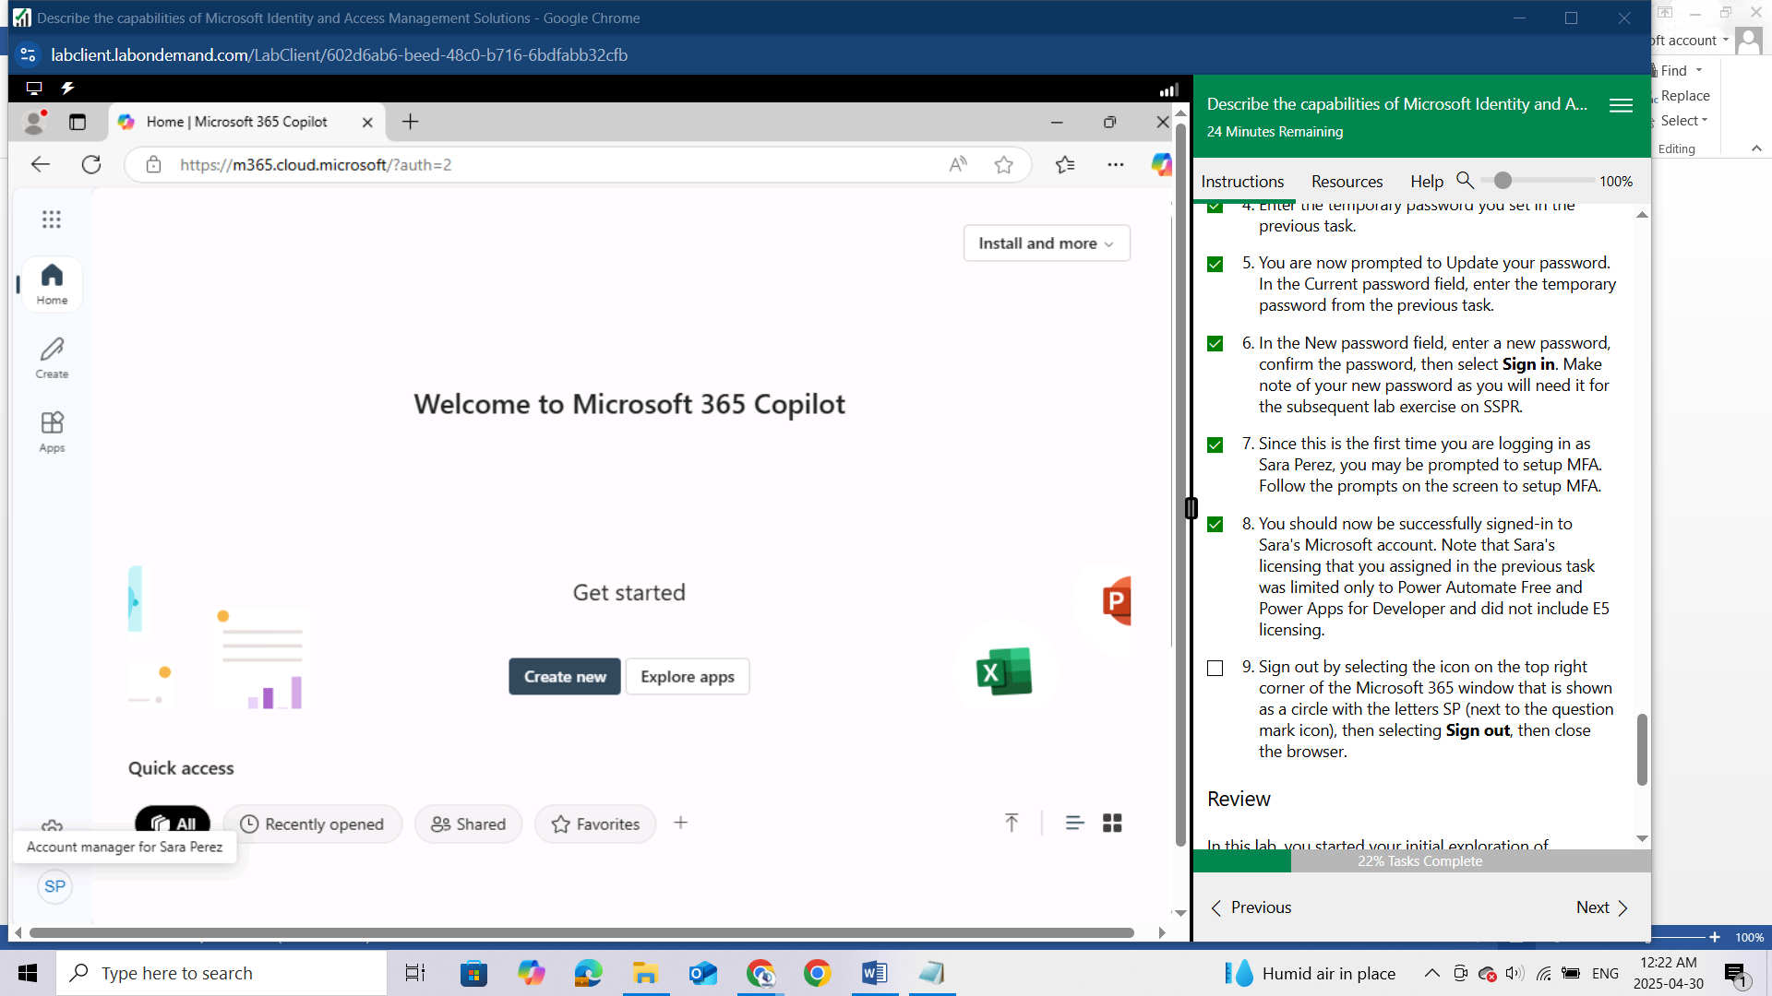

Sign out by selecting the icon on the top right corner of the Microsoft 365 window that is shown as a circle with the letters SP (next to the question mark icon), then selecting Sign out, then close the browser.

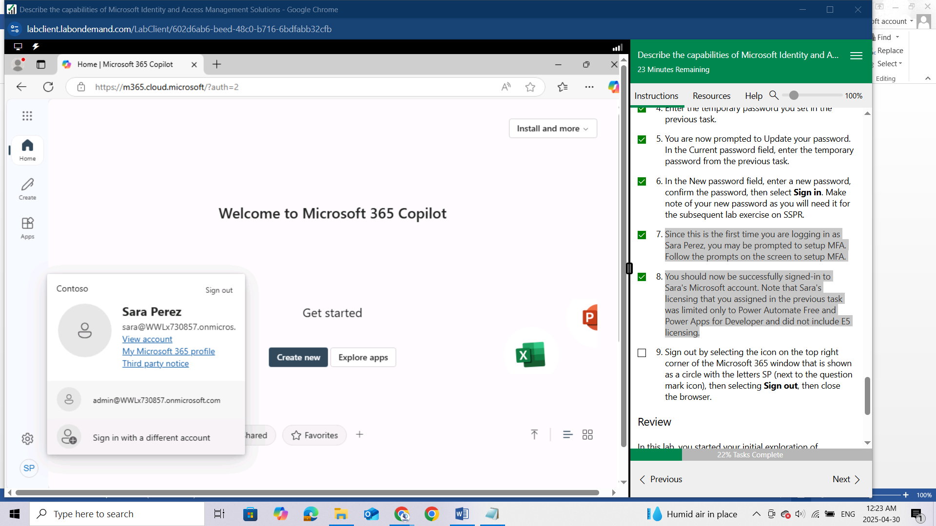

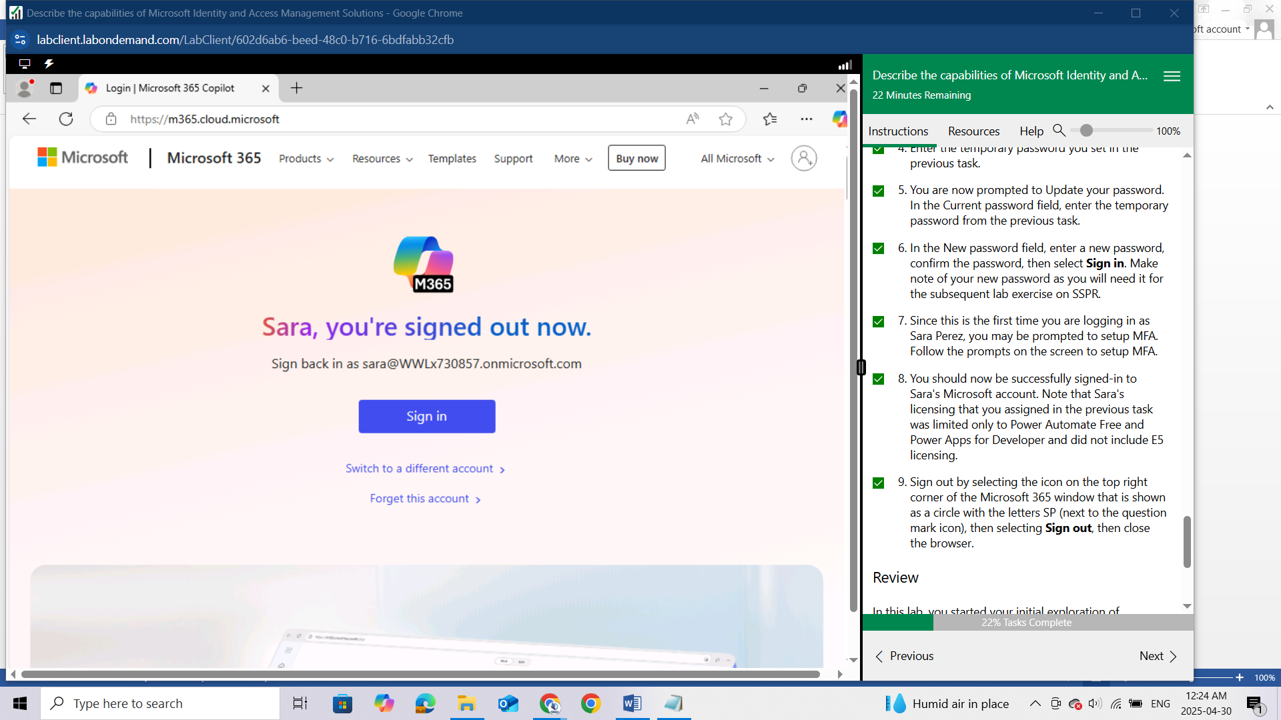

### Review

In this lab, you started your initial exploration of Microsoft Entra ID. Since subscribers to Microsoft 365 are automatically using Microsoft Entra ID, you found that you access Microsoft Entra ID features and services through either the Microsoft 365 admin portal or through the Azure portal. Whichever approach you prefer to get to the same place. You also walked through the process of creating a new user and the different setting that can be configured, including groups to which the user can be assigned, the availability of roles, and assigning of user licenses.